CHAPTER SEVEN
RESULTS AND VALIDATION ASSESSMENT
Evaluation and Deployment of 3D-Printed Automatic Weather Stations (3D-PAWS) in Kenya with Integrated Data Visualization and Monitoring Systems
Station: MTWAPA AGROMET STATION
KMD Reference Station: MTWAPA AGROMET STATION
Validation Period: 2024-08_to_2026-07

This chapter presents the results of the comparative validation assessment between the 3D-PAWS station observations and corresponding Kenya Meteorological Department (KMD) reference observations. The assessment evaluates the performance of temperature, relative humidity, atmospheric pressure, and rainfall observations using statistical analysis, quality assessment, and graphical comparison methods implemented within the 3D-PAWS Validation Toolkit.

7.1 Overview of the Results
The validation assessment was conducted for MTWAPA AGROMET STATION using MTWAPA AGROMET STATION as the Kenya Meteorological Department (KMD) reference station. The evaluation period extended from 2024-08-12 to 2026-07-30, representing a validation period of 718 days.
The assessment evaluated the performance of 3D-PAWS observations against KMD reference measurements for key meteorological variables including temperature, relative humidity, atmospheric pressure, and rainfall. The validation process included dataset standardization, observation-period alignment, quality assessment, statistical evaluation, and graphical comparison using the developed 3D-PAWS Validation Toolkit.
The analysis generated 11 parameter-level validation results. 11 parameters received formal performance assessments based on statistical criteria, while 0 parameters were not formally assessed due to limitations related to data availability, quality control filtering, or insufficient paired observations.
The results presented in this chapter provide an evaluation of the suitability of locally fabricated 3D-PAWS systems for meteorological observation network densification and support the assessment of their potential for operational deployment.
3D-PAWS Station | MTWAPA AGROMET STATION
KMD Reference Station | MTWAPA AGROMET STATION
Validation Period | 2024-08_to_2026-07
Observation Start | 2024-08-12
Observation End | 2026-07-30
Validation Days | 718
Parameters Evaluated | 11
Parameters Assessed | 11
Parameters Not Assessed | 0

7.2 Dataset Availability, Completeness and Quality Assessment
This section presents the availability, completeness, and quality assessment of observations used for the validation exercise. Sensor-level quality information from the 3D-PAWS system is presented separately from daily validation coverage used for comparison with the Kenya Meteorological Department (KMD) reference dataset.

7.2.1 3D-PAWS Sensor Data Quality Assessment
Parameter | Sensor | Observations | Valid | Validity (%) | QC Flags | Missing | Quality Level
Temperature | mt1 | 278996 | 263062 | 94.29% | 15922 | 12 | ACCEPTABLE QUALITY
Humidity | sh1 | 278996 | 278990 | 100.00% | 0 | 6 | HIGH QUALITY
Pressure | bp1 | 278996 | 263058 | 94.29% | 15938 | 0 | ACCEPTABLE QUALITY
Sensor-level quality control was performed using the variable-specific validation rules implemented in the 3D-PAWS Validation Toolkit. Valid observations were retained for statistical evaluation, while quality-flagged observations were identified and handled separately. For rainfall variables, zero observations were retained as valid measurements because they represent actual dry conditions rather than missing data.

7.2.2 Daily Validation Coverage
Parameter | Paired Days | Missing Days | Coverage (%)
Maximum Temperature | 160 | 558 | 22.3%
Minimum Temperature | 379 | 339 | 52.8%
Mean Temperature | 159 | 559 | 22.1%
Maximum Relative Humidity | 566 | 152 | 78.8%
Minimum Relative Humidity | 566 | 152 | 78.8%
Mean Relative Humidity | 566 | 152 | 78.8%
Maximum Pressure | 5 | 713 | 0.7%
Minimum Pressure | 5 | 713 | 0.7%
Mean Pressure | 5 | 713 | 0.7%
Daily Rainfall (Rain Gauge 1) | 618 | 100 | 86.1%
Daily Rainfall (Rain Gauge 2) | 618 | 100 | 86.1%
Daily validation coverage represents the proportion of observations where 3D-PAWS and KMD measurements were available for direct comparison. Differences in coverage may result from data availability, quality-control filtering, and differences in daily record completeness. Statistical performance metrics were calculated only using paired observations within the common validation period.
The validation assessment included 11 meteorological parameters. Parameter-specific coverage values were considered during interpretation to ensure that reported statistics represent available paired observations.

7.3 Validation Statistics and Performance Assessment
The validation assessment compares paired 3D-PAWS and Kenya Meteorological Department (KMD) observations within the common validation period. Statistical performance metrics were calculated using observations available from both systems after the applicable quality-control and data-availability procedures.

7.3.1 Statistical Performance Indicators
The comparison uses several complementary statistical indicators to evaluate agreement between 3D-PAWS and KMD observations. Bias indicates the mean systematic difference between the two observation systems. Mean Absolute Error (MAE) represents the average magnitude of the absolute differences, while Root Mean Square Error (RMSE) gives greater weight to larger differences.
The correlation coefficient (r) is used to evaluate the strength of the linear temporal relationship between 3D-PAWS and KMD observations. The coefficient of determination (R²) indicates the proportion of variance in the KMD observations that is explained by the corresponding 3D-PAWS observations.

7.3.2 Performance Classification
Performance classification was based on the parameter-specific criteria implemented in the 3D-PAWS Validation Toolkit. Where WMO requirement criteria were available, the assessment considers the Goal, Breakthrough, and Threshold levels associated with the relevant meteorological parameter.
A parameter classified as Threshold met the implemented Threshold criterion for the corresponding performance measure. Parameters classified as Below Threshold did not meet the implemented Threshold criterion. Such classification is interpreted together with correlation, bias, MAE, RMSE, observation coverage, and the intended operational application of the parameter.

7.3.3 Interpretation of Statistical Agreement
Statistical indicators are interpreted collectively rather than using a single metric in isolation. Strong correlation indicates that the 3D-PAWS system follows the temporal variability observed by the KMD reference system, while bias and error statistics indicate the degree of numerical agreement between the two datasets.
Differences between the two observation systems may also reflect sensor characteristics, calibration, station exposure, elevation effects, precipitation spatial variability, and differences in measurement procedures. Consequently, statistical classifications are considered together with the physical and operational characteristics of each parameter.

7.4 Temperature Results

Maximum Temperature
Data status: ACCEPTABLE QUALITY | Paired observations: 160 | Comparison missing: 558 | Faulty observations: 15922
Descriptive statistics
Statistic | 3DPAWS | KMD
Observations | 160 | 160
Mean | 30.444 | 29.888
Median | 30.195 | 29.450
Minimum | 23.500 | 21.400
Maximum | 34.440 | 33.800
Standard Deviation | 1.843 | 1.964
Variance | 3.397 | 3.856
Validation statistics
Metric | Value
Bias | 0.555 °C
Mean Absolute Error (MAE) | 0.763 °C
Root Mean Square Error (RMSE) | 1.206 °C
Correlation coefficient (r) | 0.843
Coefficient of determination (R²) | 0.710
Performance assessment: Threshold
WMO requirement: 253
Criterion | Value
Goal | 0.500 °C
Breakthrough | 1.000 °C
Threshold | 2.000 °C
Interpretation: The paired observations show strong linear agreement between 3DPAWS and KMD measurements (r = 0.843). The coefficient of determination was R² = 0.710. The mean bias was 0.555 °C, indicating that the 3DPAWS observations were generally higher than the KMD observations. The mean absolute error was 0.763 °C. The root mean square error was 1.206 °C. Under the implemented performance assessment criteria, the parameter was classified as Threshold.
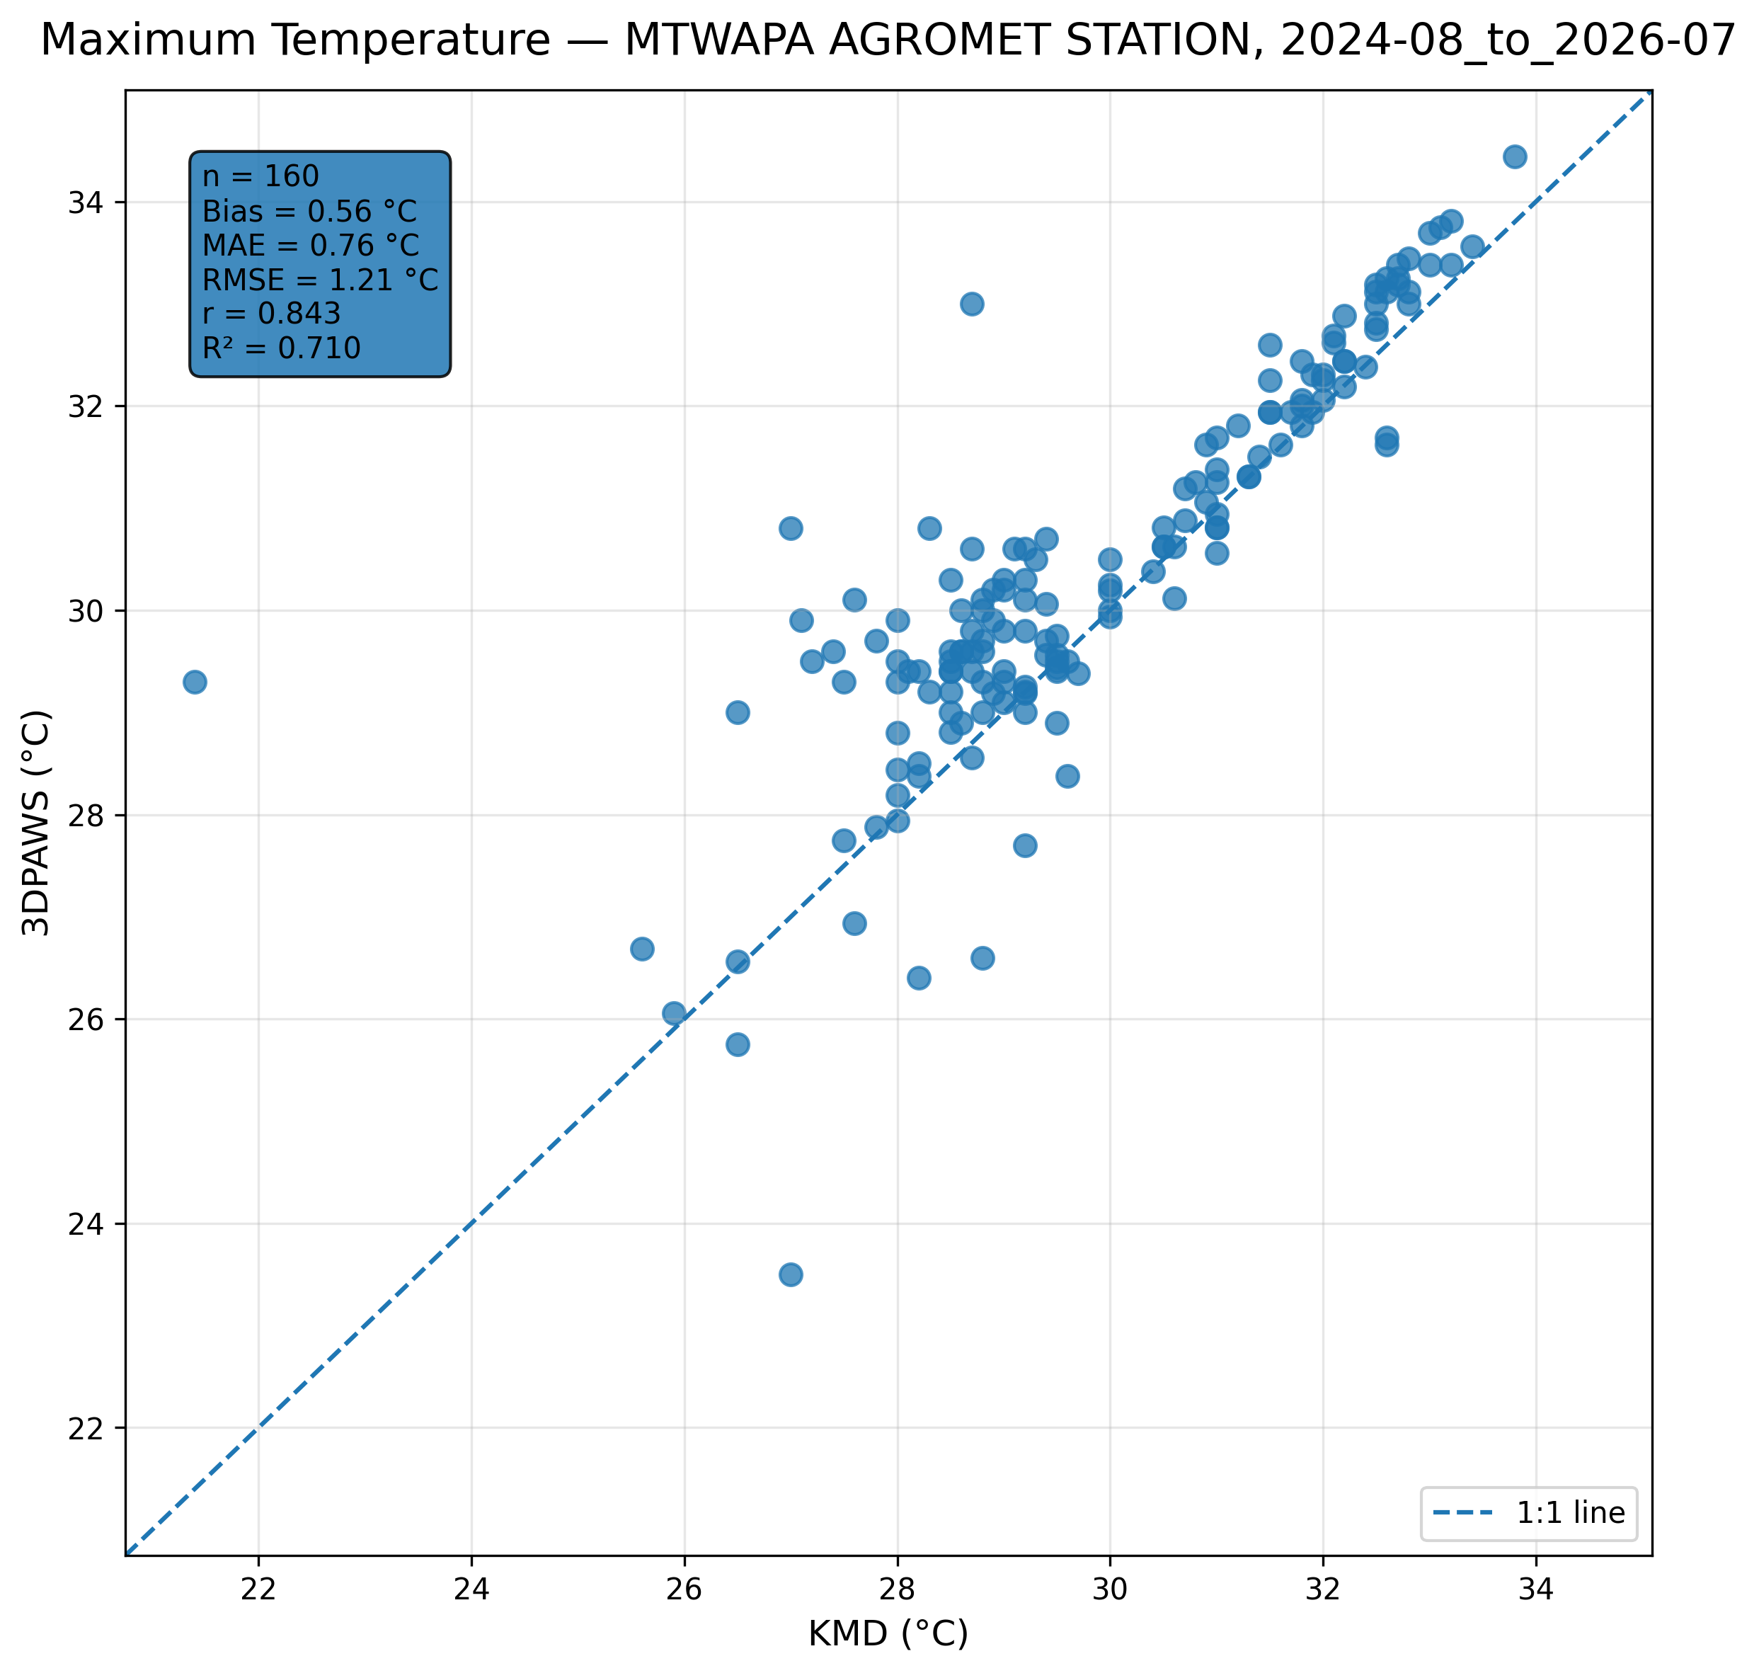
Figure 7.1: Scatter comparison of maximum temperature observations between 3DPAWS and KMD at MTWAPA AGROMET STATION for 2024-08_to_2026-07.
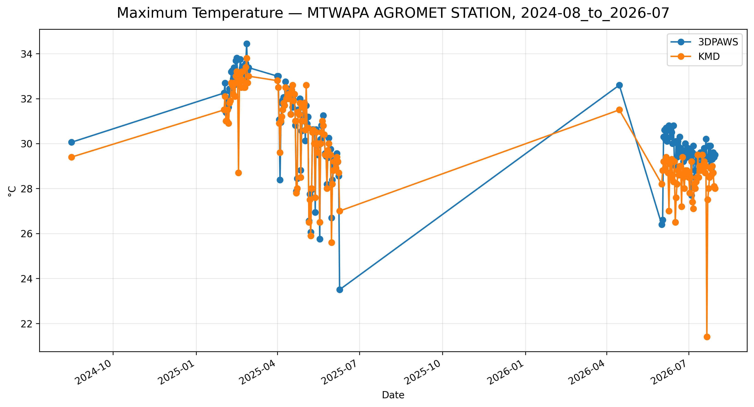
Figure 7.2: Time-series comparison of daily maximum temperature observations between 3DPAWS and KMD at MTWAPA AGROMET STATION for 2024-08_to_2026-07.

Minimum Temperature
Data status: ACCEPTABLE QUALITY | Paired observations: 379 | Comparison missing: 339 | Faulty observations: 15922
Descriptive statistics
Statistic | 3DPAWS | KMD
Observations | 379 | 379
Mean | 24.036 | 24.275
Median | 24.100 | 24.500
Minimum | 20.000 | 20.300
Maximum | 31.440 | 28.200
Standard Deviation | 1.495 | 1.283
Variance | 2.235 | 1.645
Validation statistics
Metric | Value
Bias | -0.240 °C
Mean Absolute Error (MAE) | 0.623 °C
Root Mean Square Error (RMSE) | 1.074 °C
Correlation coefficient (r) | 0.725
Coefficient of determination (R²) | 0.526
Performance assessment: Threshold
WMO requirement: 253
Criterion | Value
Goal | 0.500 °C
Breakthrough | 1.000 °C
Threshold | 2.000 °C
Interpretation: The paired observations show moderate linear agreement between 3DPAWS and KMD measurements (r = 0.725). The coefficient of determination was R² = 0.526. The mean bias was -0.240 °C, indicating that the 3DPAWS observations were generally lower than the KMD observations. The mean absolute error was 0.623 °C. The root mean square error was 1.074 °C. Under the implemented performance assessment criteria, the parameter was classified as Threshold.
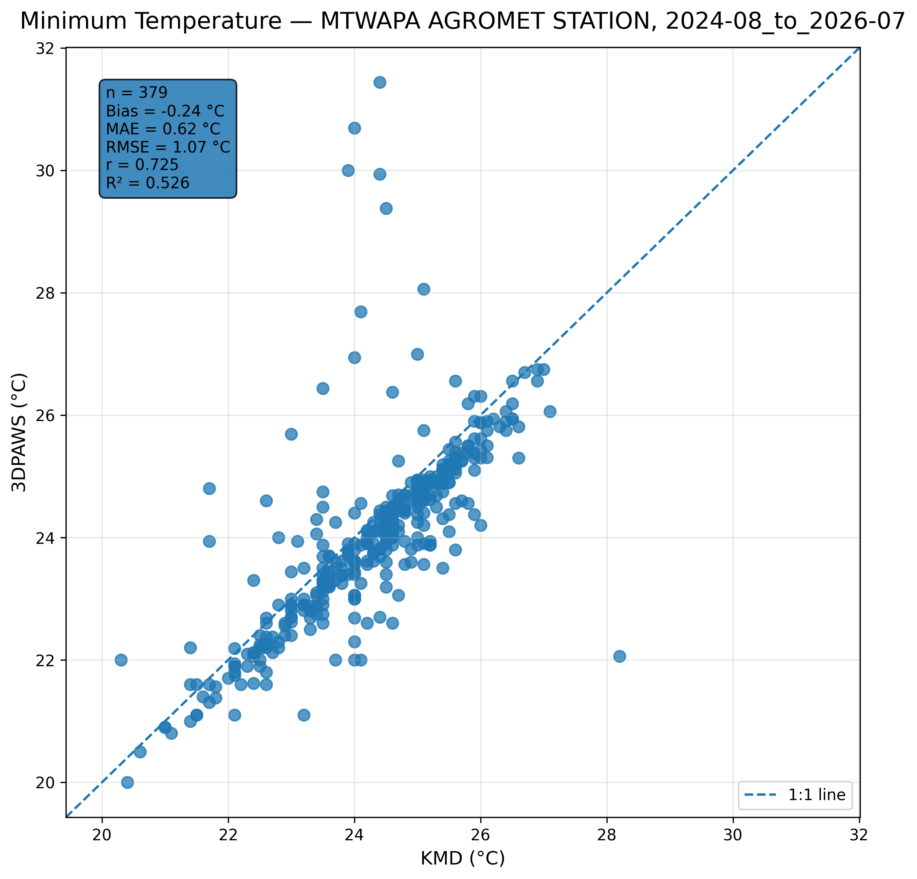
Figure 7.3: Scatter comparison of minimum temperature observations between 3DPAWS and KMD at MTWAPA AGROMET STATION for 2024-08_to_2026-07.
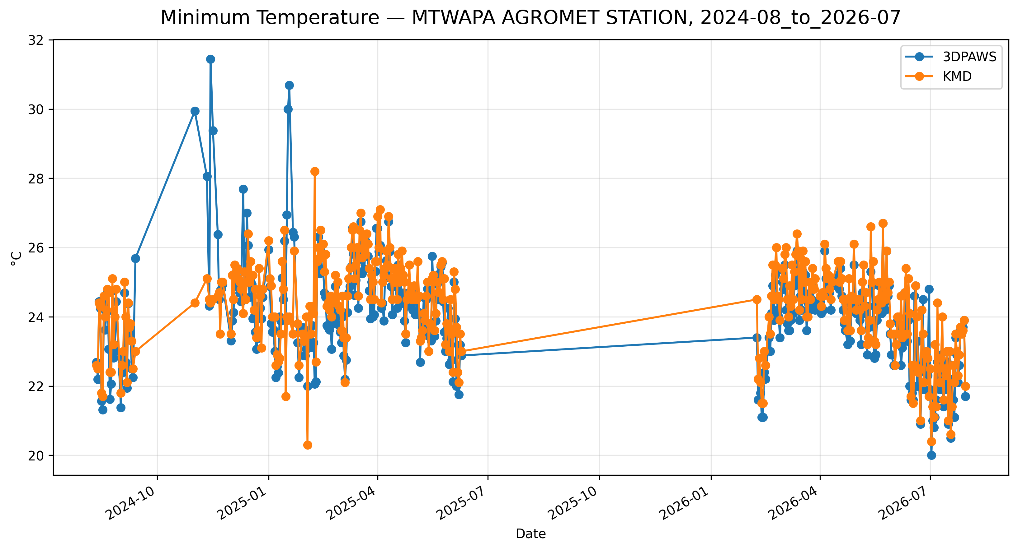
Figure 7.4: Time-series comparison of daily minimum temperature observations between 3DPAWS and KMD at MTWAPA AGROMET STATION for 2024-08_to_2026-07.

Mean Temperature
Data status: ACCEPTABLE QUALITY | Paired observations: 159 | Comparison missing: 559 | Faulty observations: 15922
Descriptive statistics
Statistic | 3DPAWS | KMD
Observations | 159 | 159
Mean | 26.735 | 26.917
Median | 26.545 | 26.850
Minimum | 23.169 | 21.750
Maximum | 29.530 | 30.050
Standard Deviation | 1.303 | 1.495
Variance | 1.698 | 2.236
Validation statistics
Metric | Value
Bias | -0.182 °C
Mean Absolute Error (MAE) | 0.552 °C
Root Mean Square Error (RMSE) | 0.760 °C
Correlation coefficient (r) | 0.869
Coefficient of determination (R²) | 0.755
Performance assessment: Breakthrough
WMO requirement: 253
Criterion | Value
Goal | 0.500 °C
Breakthrough | 1.000 °C
Threshold | 2.000 °C
Interpretation: The paired observations show strong linear agreement between 3DPAWS and KMD measurements (r = 0.869). The coefficient of determination was R² = 0.755. The mean bias was -0.182 °C, indicating that the 3DPAWS observations were generally lower than the KMD observations. The mean absolute error was 0.552 °C. The root mean square error was 0.760 °C. Under the implemented performance assessment criteria, the parameter was classified as Breakthrough.
Figure 7.5: Scatter comparison of mean temperature observations between 3DPAWS and KMD at MTWAPA AGROMET STATION for 2024-08_to_2026-07.
Figure 7.6: Time-series comparison of daily mean temperature observations between 3DPAWS and KMD at MTWAPA AGROMET STATION for 2024-08_to_2026-07.

7.5 Relative Humidity Results

Maximum Relative Humidity
Data status: HIGH QUALITY | Paired observations: 566 | Comparison missing: 152
Descriptive statistics
Statistic | 3DPAWS | KMD
Observations | 566 | 566
Mean | 89.642 | 65.640
Median | 91.245 | 64.800
Minimum | 64.450 | 48.830
Maximum | 97.600 | 90.330
Standard Deviation | 5.325 | 7.222
Variance | 28.355 | 52.155
Validation statistics
Metric | Value
Bias | 24.001 %
Mean Absolute Error (MAE) | 24.005 %
Root Mean Square Error (RMSE) | 25.271 %
Correlation coefficient (r) | 0.232
Coefficient of determination (R²) | 0.054
Performance assessment: Below Threshold
WMO requirement: 776
Criterion | Value
Goal | 0.500 %
Breakthrough | 2.500 %
Threshold | 5.000 %
Interpretation: The paired observations show very weak linear agreement between 3DPAWS and KMD measurements (r = 0.232). The coefficient of determination was R² = 0.054. The mean bias was 24.001 %, indicating that the 3DPAWS observations were generally higher than the KMD observations. The mean absolute error was 24.005 %. The root mean square error was 25.271 %. Under the implemented performance assessment criteria, the parameter was classified as Below Threshold. The relatively high correlation indicates that 3D-PAWS successfully captured temporal humidity variability despite differences in absolute values.
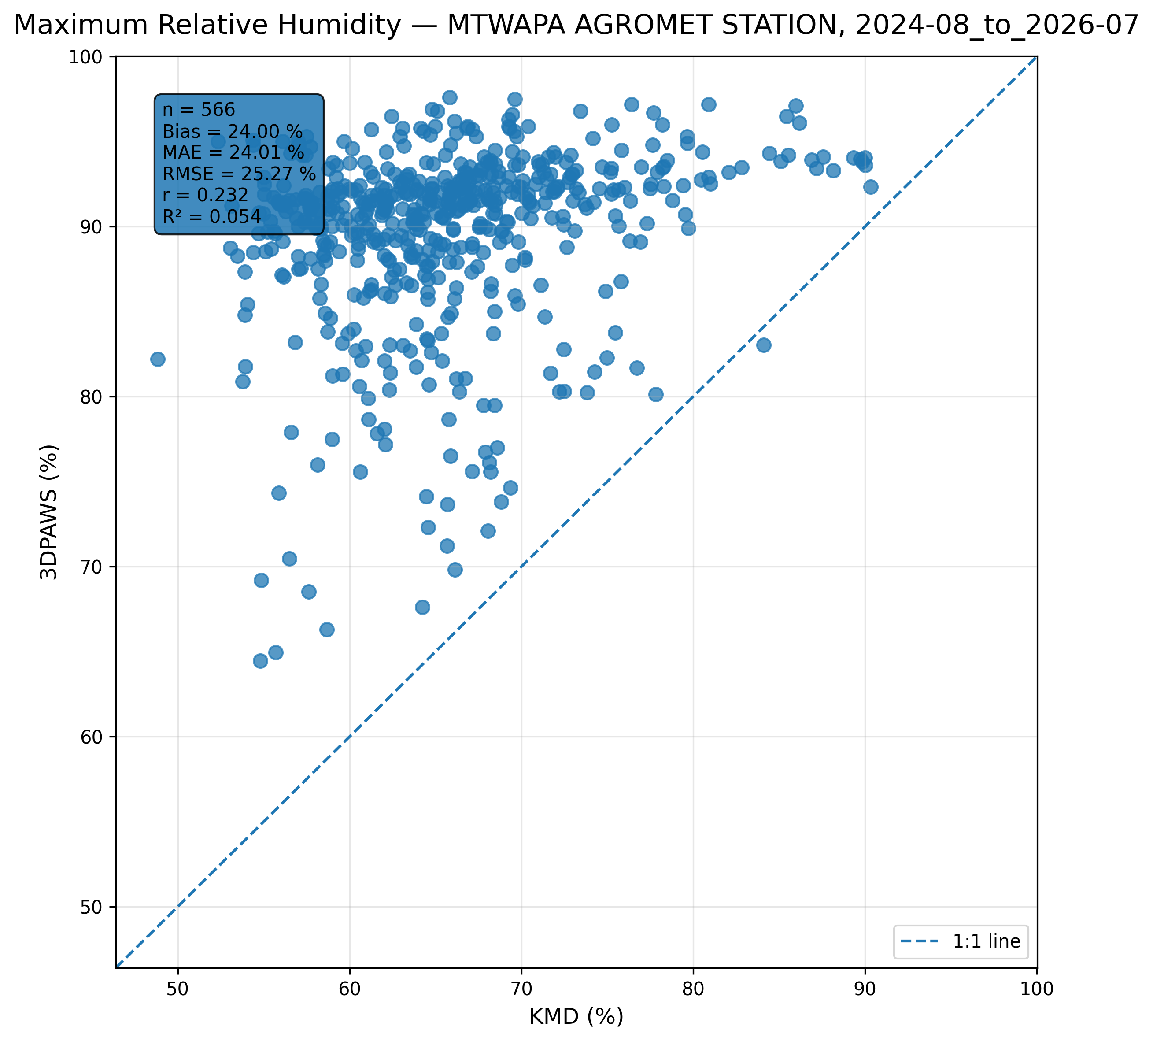
Figure 7.7: Scatter comparison of maximum relative humidity observations between 3DPAWS and KMD at MTWAPA AGROMET STATION for 2024-08_to_2026-07.
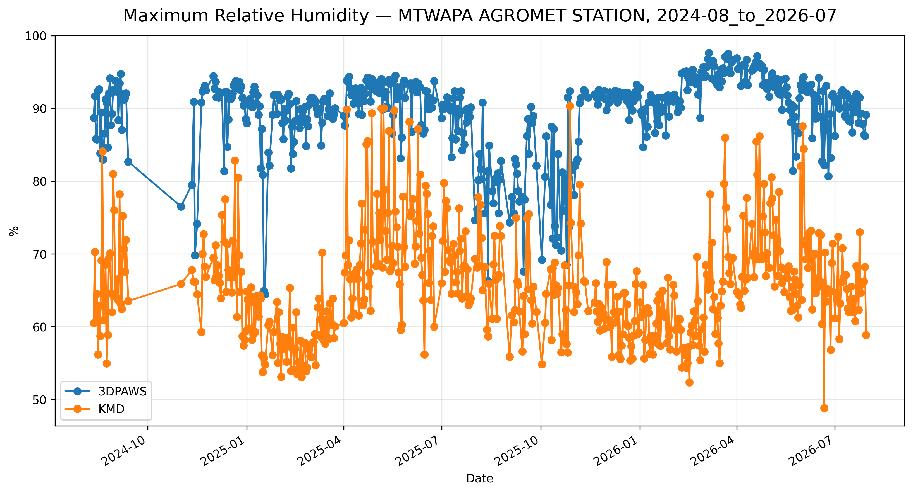
Figure 7.8: Time-series comparison of daily maximum relative humidity observations between 3DPAWS and KMD at MTWAPA AGROMET STATION for 2024-08_to_2026-07.

Minimum Relative Humidity
Data status: HIGH QUALITY | Paired observations: 566 | Comparison missing: 152
Descriptive statistics
Statistic | 3DPAWS | KMD
Observations | 566 | 566
Mean | 66.038 | 65.640
Median | 65.170 | 64.800
Minimum | 46.000 | 48.830
Maximum | 91.800 | 90.330
Standard Deviation | 7.169 | 7.222
Variance | 51.397 | 52.155
Validation statistics
Metric | Value
Bias | 0.397 %
Mean Absolute Error (MAE) | 3.924 %
Root Mean Square Error (RMSE) | 5.994 %
Correlation coefficient (r) | 0.654
Coefficient of determination (R²) | 0.428
Performance assessment: Below Threshold
WMO requirement: 776
Criterion | Value
Goal | 0.500 %
Breakthrough | 2.500 %
Threshold | 5.000 %
Interpretation: The paired observations show moderate linear agreement between 3DPAWS and KMD measurements (r = 0.654). The coefficient of determination was R² = 0.428. The mean bias was 0.397 %, indicating that the 3DPAWS observations were generally higher than the KMD observations. The mean absolute error was 3.924 %. The root mean square error was 5.994 %. Under the implemented performance assessment criteria, the parameter was classified as Below Threshold. The relatively high correlation indicates that 3D-PAWS successfully captured temporal humidity variability despite differences in absolute values.
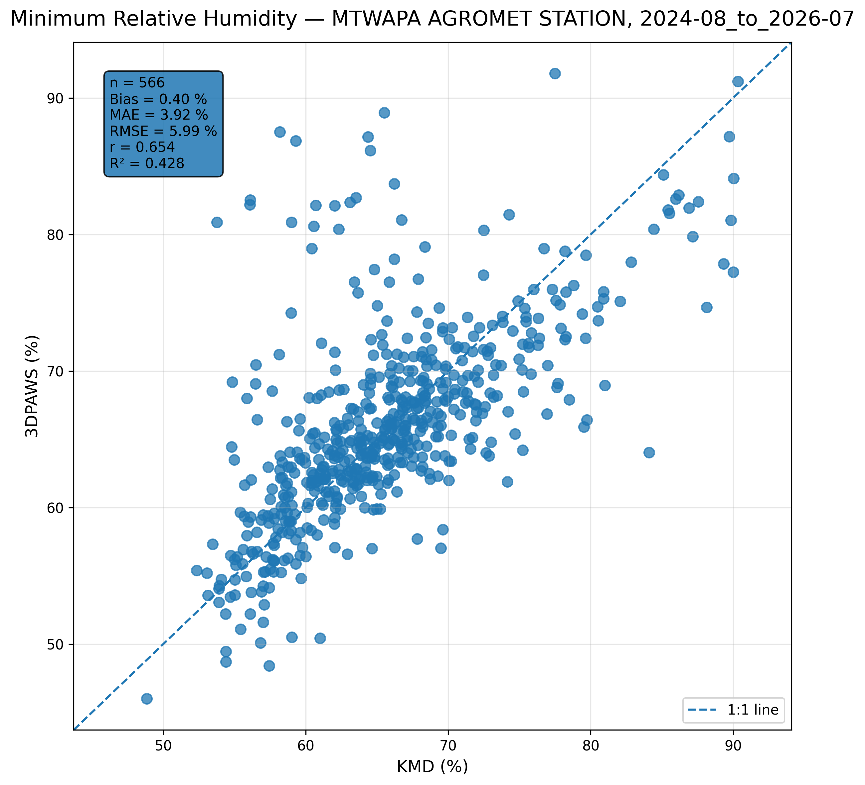
Figure 7.9: Scatter comparison of minimum relative humidity observations between 3DPAWS and KMD at MTWAPA AGROMET STATION for 2024-08_to_2026-07.
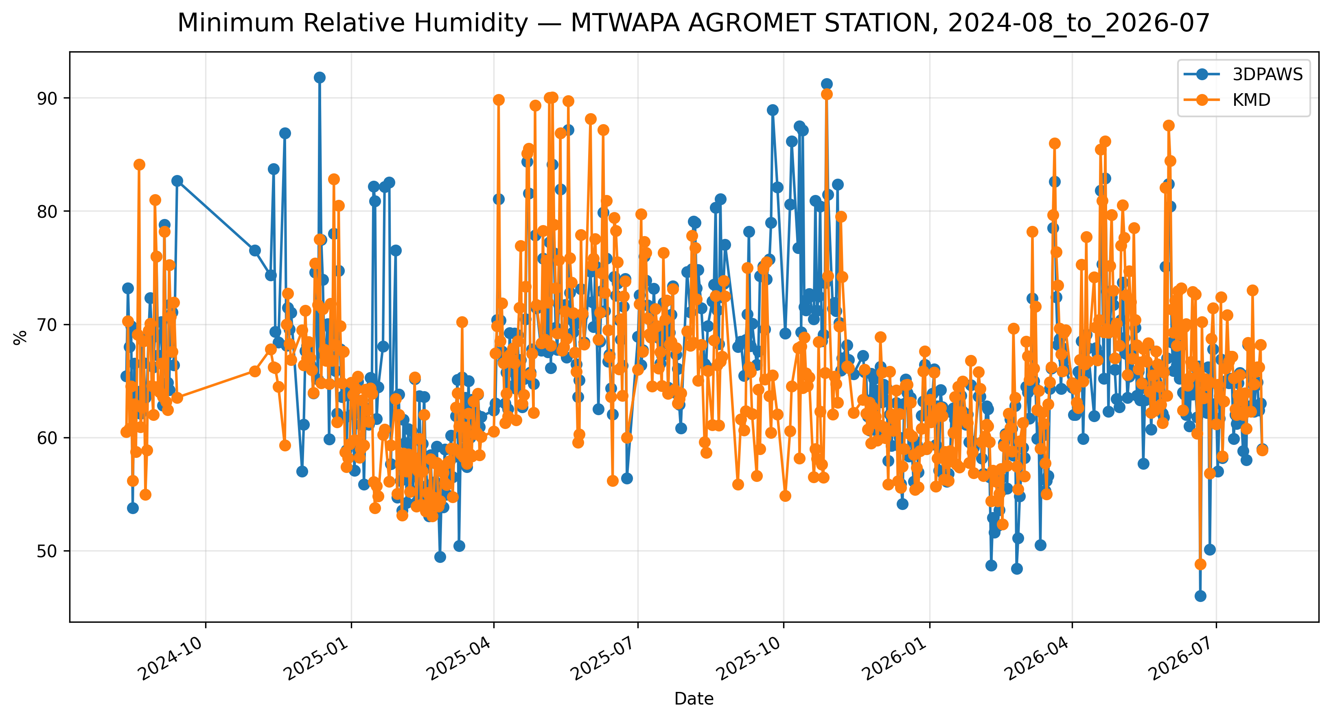
Figure 7.10: Time-series comparison of daily minimum relative humidity observations between 3DPAWS and KMD at MTWAPA AGROMET STATION for 2024-08_to_2026-07.

Mean Relative Humidity
Data status: HIGH QUALITY | Paired observations: 566 | Comparison missing: 152
Descriptive statistics
Statistic | 3DPAWS | KMD
Observations | 566 | 566
Mean | 79.464 | 65.640
Median | 78.991 | 64.800
Minimum | 63.070 | 48.830
Maximum | 94.784 | 90.330
Standard Deviation | 4.533 | 7.222
Variance | 20.547 | 52.155
Validation statistics
Metric | Value
Bias | 13.824 %
Mean Absolute Error (MAE) | 13.857 %
Root Mean Square Error (RMSE) | 14.732 %
Correlation coefficient (r) | 0.714
Coefficient of determination (R²) | 0.509
Performance assessment: Below Threshold
WMO requirement: 776
Criterion | Value
Goal | 0.500 %
Breakthrough | 2.500 %
Threshold | 5.000 %
Interpretation: The paired observations show moderate linear agreement between 3DPAWS and KMD measurements (r = 0.714). The coefficient of determination was R² = 0.509. The mean bias was 13.824 %, indicating that the 3DPAWS observations were generally higher than the KMD observations. The mean absolute error was 13.857 %. The root mean square error was 14.732 %. Under the implemented performance assessment criteria, the parameter was classified as Below Threshold. The relatively high correlation indicates that 3D-PAWS successfully captured temporal humidity variability despite differences in absolute values.
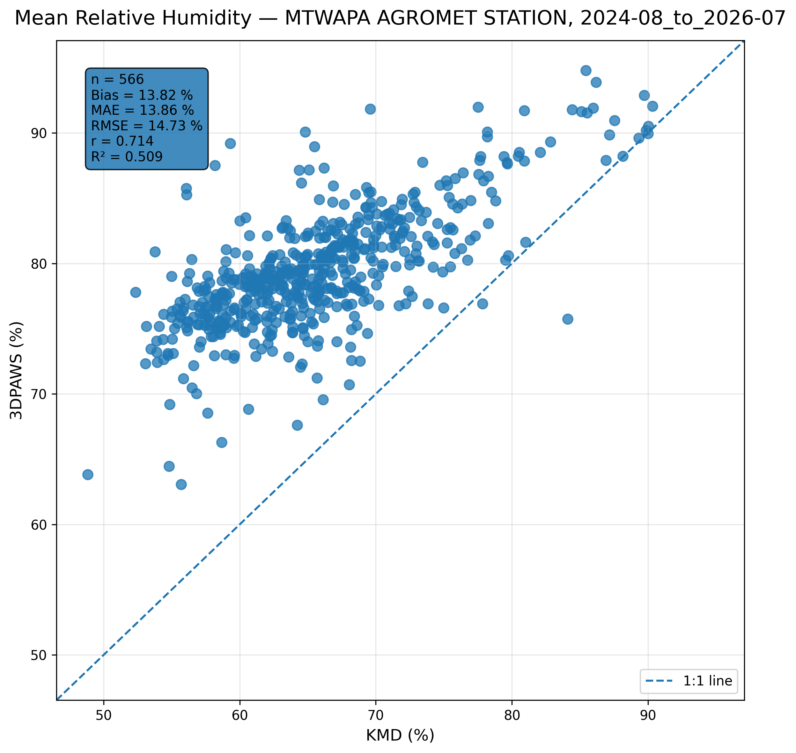
Figure 7.11: Scatter comparison of mean relative humidity observations between 3DPAWS and KMD at MTWAPA AGROMET STATION for 2024-08_to_2026-07.
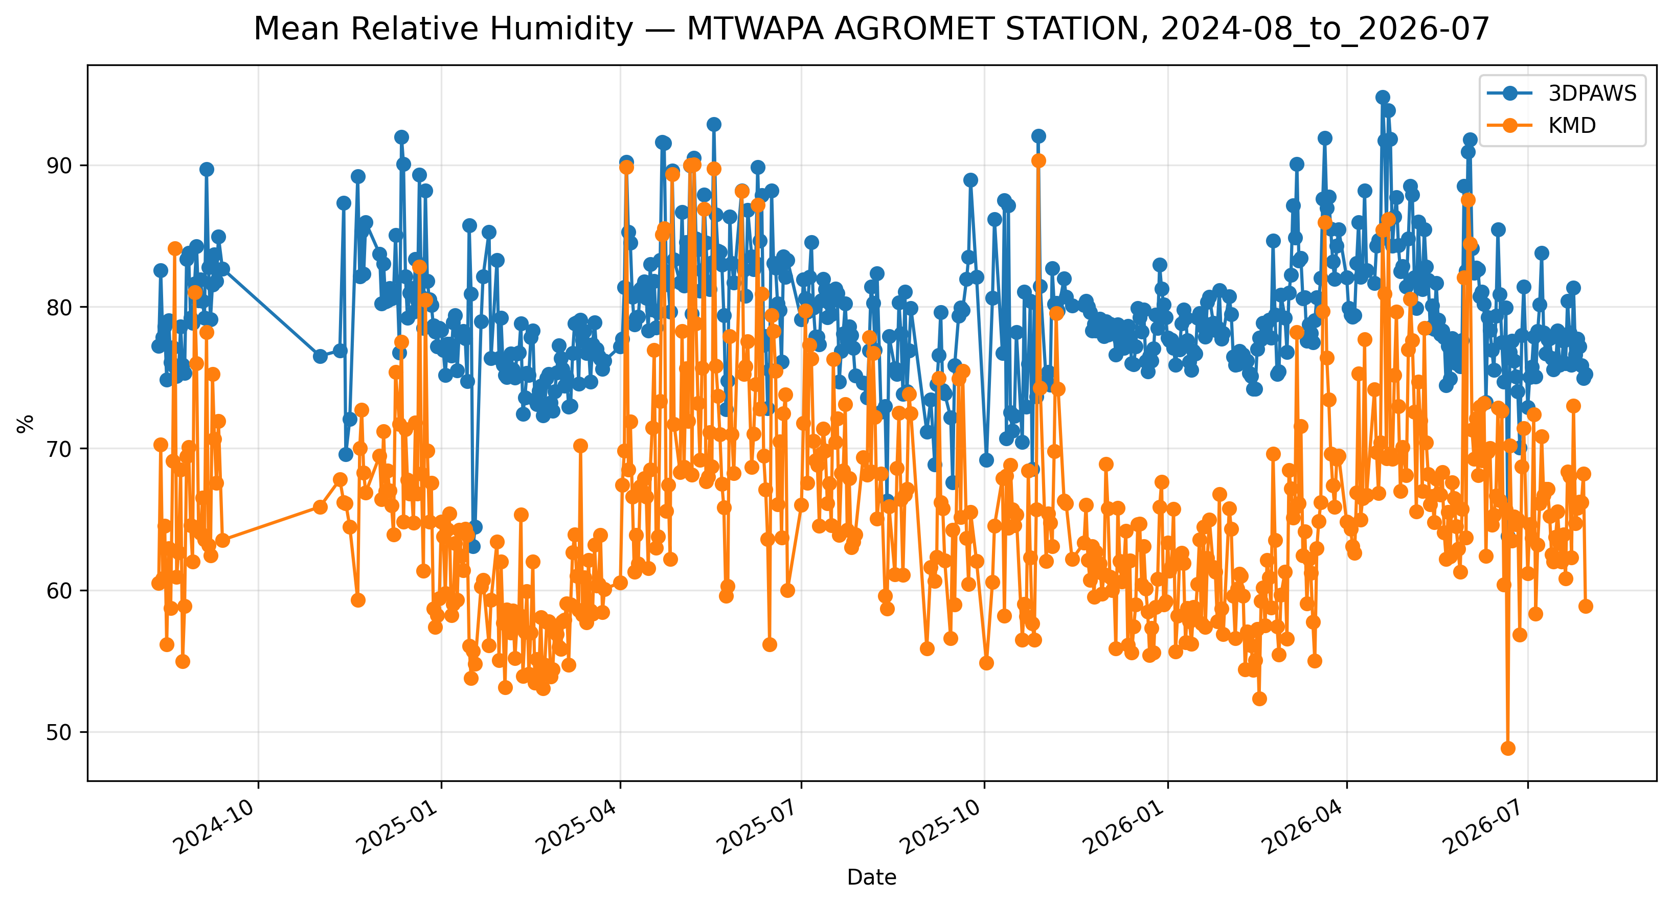
Figure 7.12: Time-series comparison of daily mean relative humidity observations between 3DPAWS and KMD at MTWAPA AGROMET STATION for 2024-08_to_2026-07.

7.6 Pressure Results

Maximum Pressure
Data status: ACCEPTABLE QUALITY | Paired observations: 5 | Comparison missing: 713 | Faulty observations: 15938
Descriptive statistics
Statistic | 3DPAWS | KMD
Observations | 5 | 5
Mean | 1013.498 | 955.314
Median | 1015.200 | 952.600
Minimum | 1009.900 | 904.000
Maximum | 1016.285 | 1008.500
Standard Deviation | 2.922 | 51.585
Variance | 8.537 | 2661.023
Validation statistics
Metric | Value
Bias | 58.184 hPa
Mean Absolute Error (MAE) | 58.184 hPa
Root Mean Square Error (RMSE) | 75.801 hPa
Correlation coefficient (r) | -0.932
Coefficient of determination (R²) | 0.868
Performance assessment: Below Threshold
WMO requirement: 250
Criterion | Value
Goal | 0.500 hPa
Breakthrough | 1.000 hPa
Threshold | 1.000 hPa
Interpretation: The paired observations show very strong linear agreement between 3DPAWS and KMD measurements (r = -0.932). The coefficient of determination was R² = 0.868. The mean bias was 58.184 hPa, indicating that the 3DPAWS observations were generally higher than the KMD observations. The mean absolute error was 58.184 hPa. The root mean square error was 75.801 hPa. Under the implemented performance assessment criteria, the parameter was classified as Below Threshold. Differences in pressure variability may be associated with elevation correction, sensor response characteristics, or local exposure conditions.
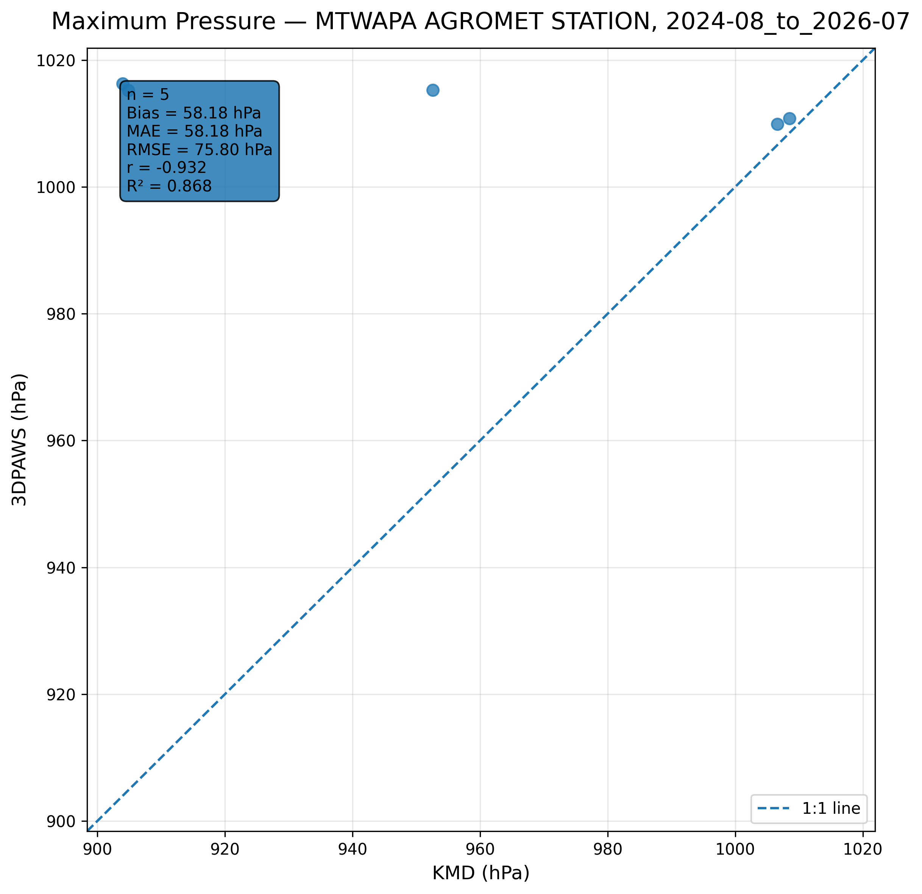
Figure 7.13: Scatter comparison of maximum pressure observations between 3DPAWS and KMD at MTWAPA AGROMET STATION for 2024-08_to_2026-07.
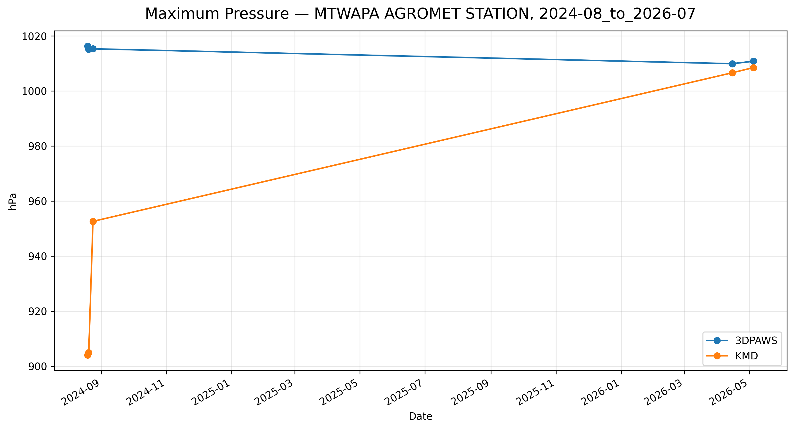
Figure 7.14: Time-series comparison of daily maximum pressure observations between 3DPAWS and KMD at MTWAPA AGROMET STATION for 2024-08_to_2026-07.

Minimum Pressure
Data status: ACCEPTABLE QUALITY | Paired observations: 5 | Comparison missing: 713 | Faulty observations: 15938
Descriptive statistics
Statistic | 3DPAWS | KMD
Observations | 5 | 5
Mean | 923.834 | 955.314
Median | 869.323 | 952.600
Minimum | 869.323 | 904.000
Maximum | 1007.000 | 1008.500
Standard Deviation | 74.648 | 51.585
Variance | 5572.398 | 2661.023
Validation statistics
Metric | Value
Bias | -31.480 hPa
Mean Absolute Error (MAE) | 31.480 hPa
Root Mean Square Error (RMSE) | 43.380 hPa
Correlation coefficient (r) | 0.924
Coefficient of determination (R²) | 0.855
Performance assessment: Below Threshold
WMO requirement: 250
Criterion | Value
Goal | 0.500 hPa
Breakthrough | 1.000 hPa
Threshold | 1.000 hPa
Interpretation: The paired observations show very strong linear agreement between 3DPAWS and KMD measurements (r = 0.924). The coefficient of determination was R² = 0.855. The mean bias was -31.480 hPa, indicating that the 3DPAWS observations were generally lower than the KMD observations. The mean absolute error was 31.480 hPa. The root mean square error was 43.380 hPa. Under the implemented performance assessment criteria, the parameter was classified as Below Threshold. Differences in pressure variability may be associated with elevation correction, sensor response characteristics, or local exposure conditions.
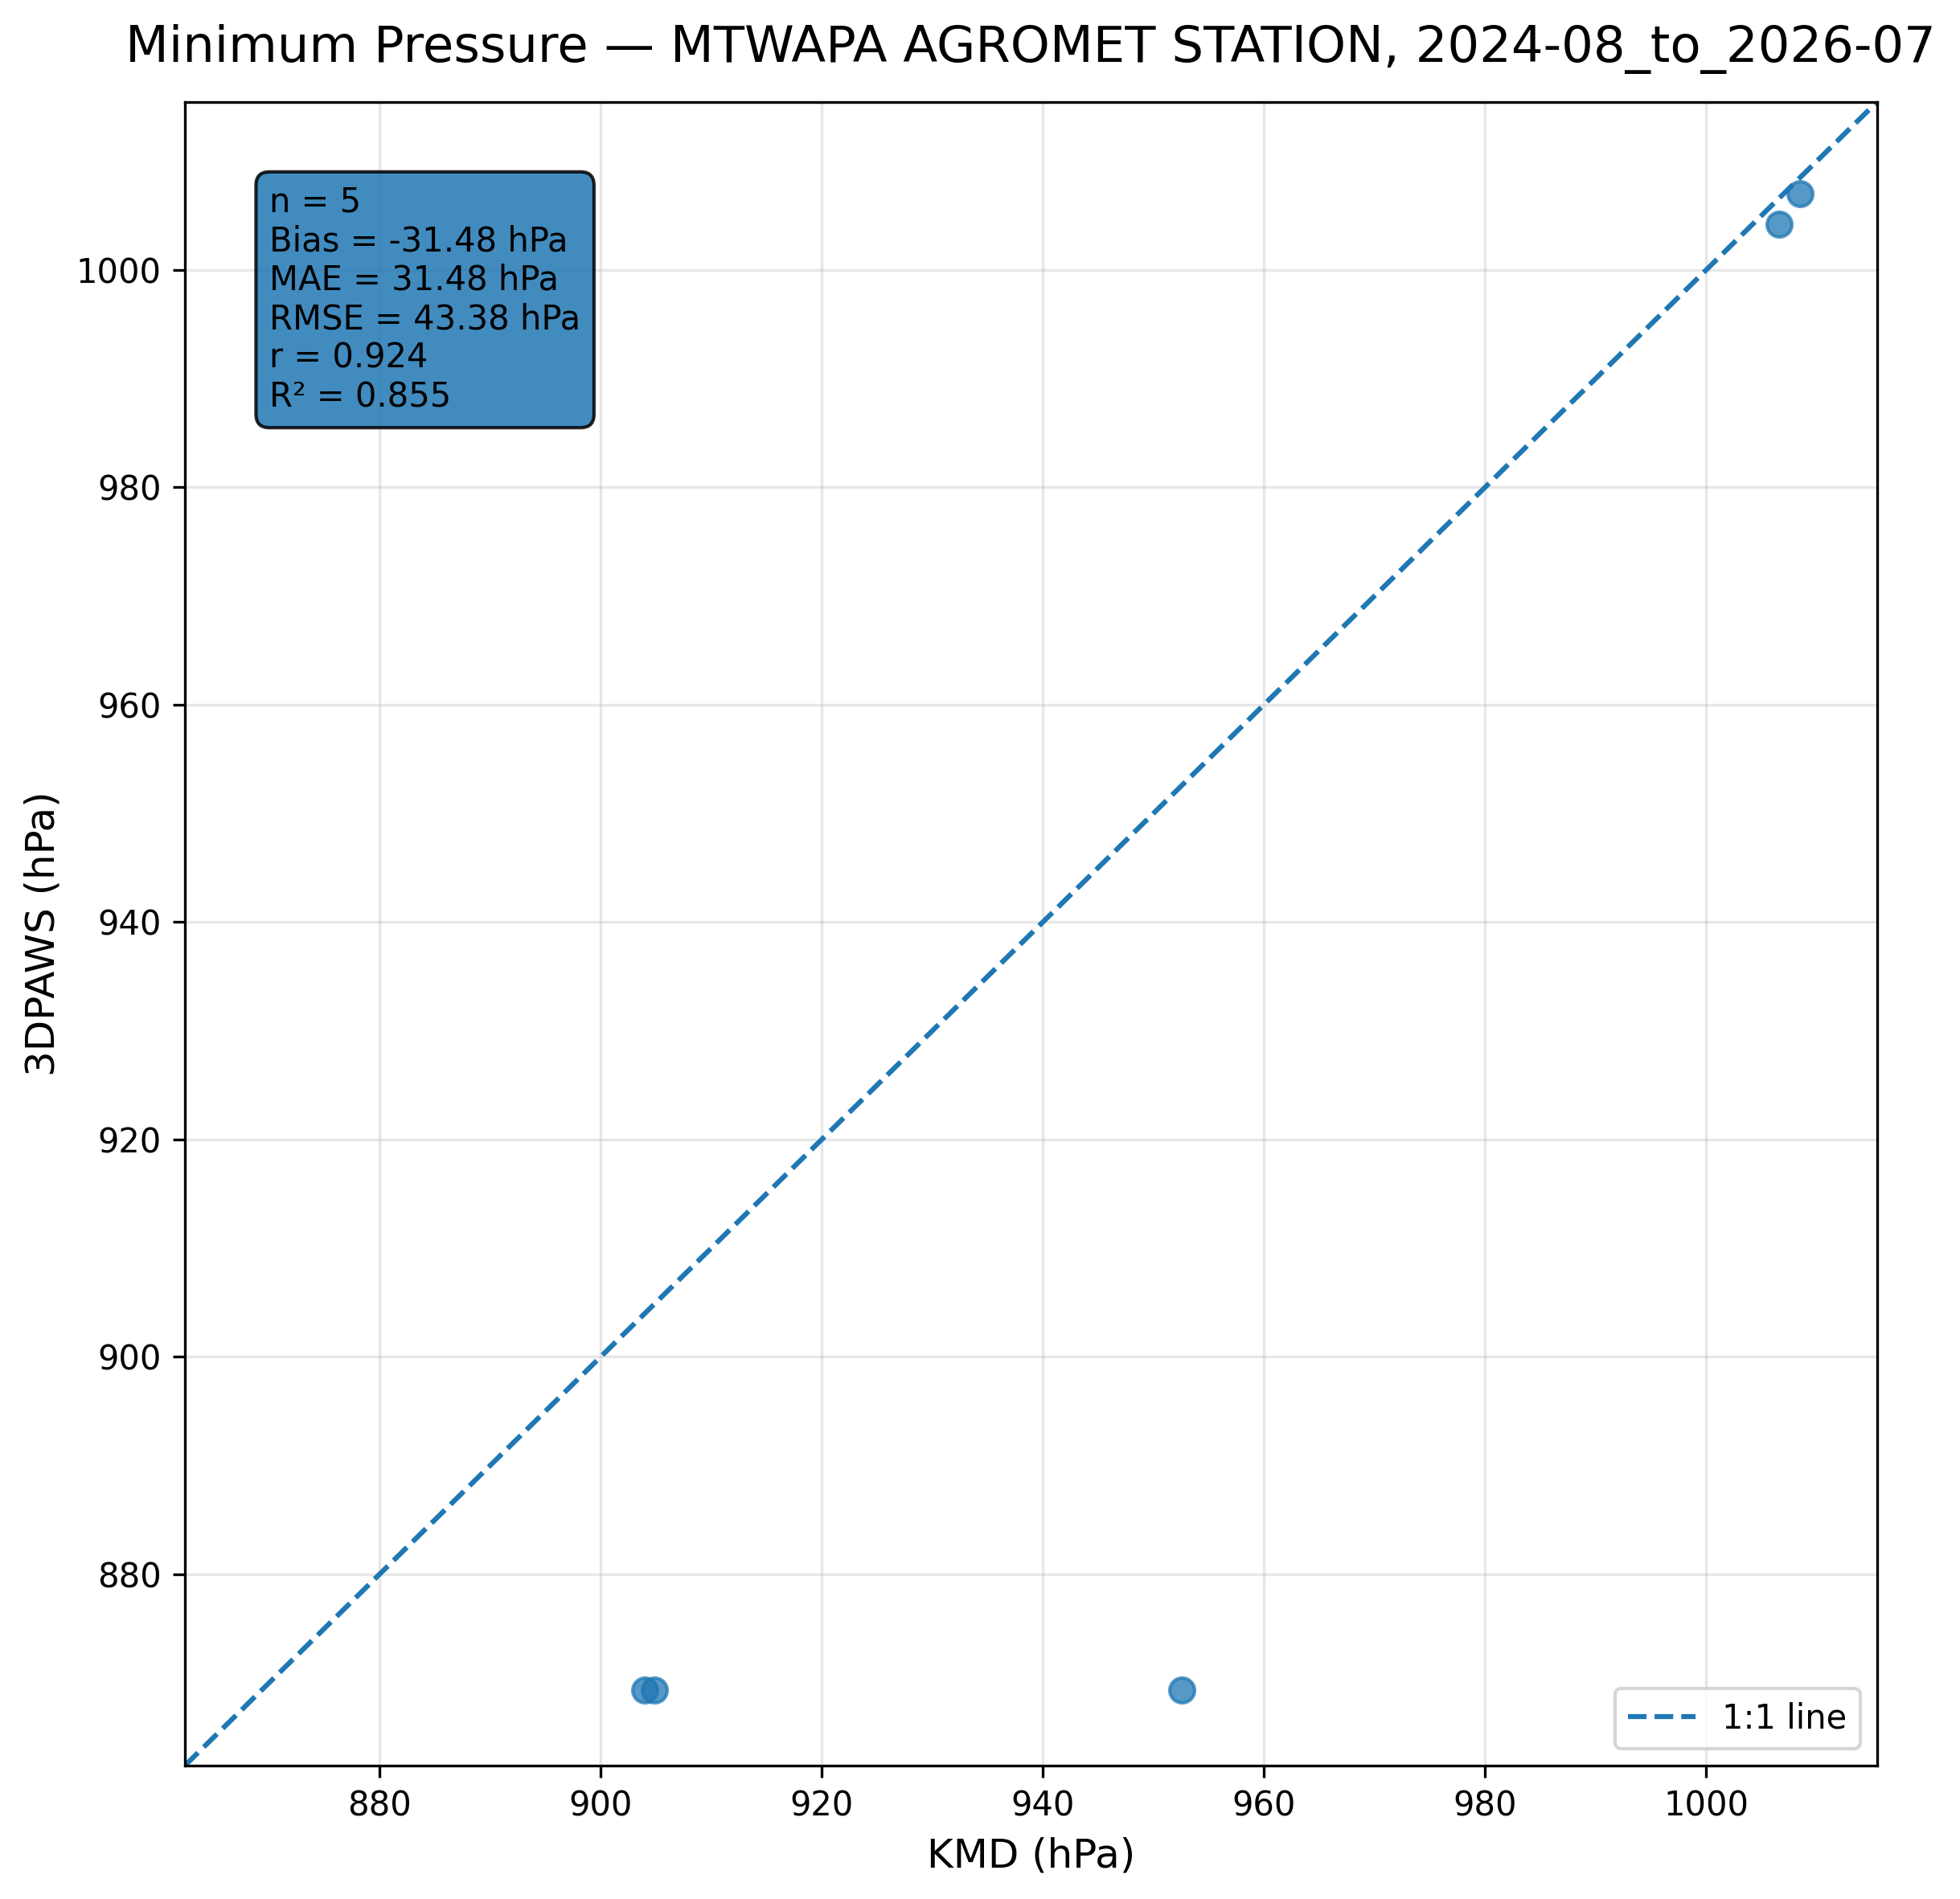
Figure 7.15: Scatter comparison of minimum pressure observations between 3DPAWS and KMD at MTWAPA AGROMET STATION for 2024-08_to_2026-07.
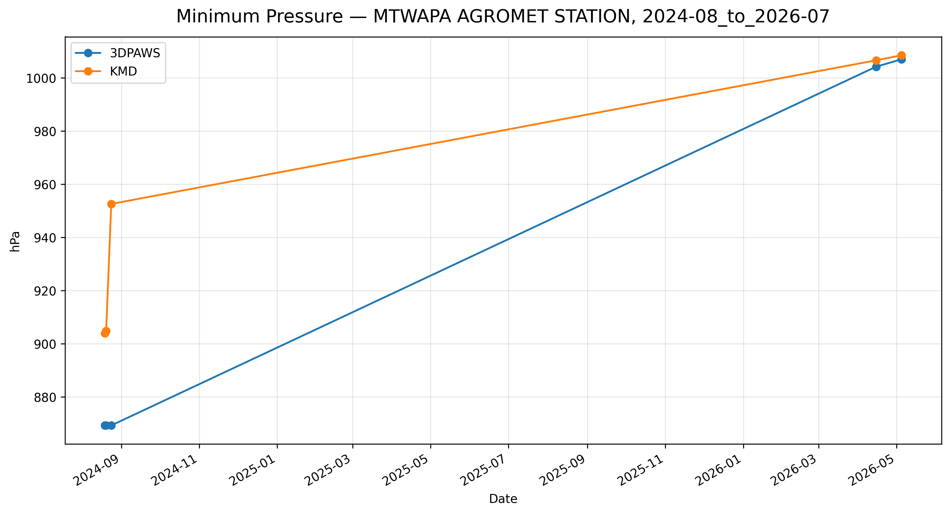
Figure 7.16: Time-series comparison of daily minimum pressure observations between 3DPAWS and KMD at MTWAPA AGROMET STATION for 2024-08_to_2026-07.

Mean Pressure
Data status: ACCEPTABLE QUALITY | Paired observations: 5 | Comparison missing: 713 | Faulty observations: 15938
Descriptive statistics
Statistic | 3DPAWS | KMD
Observations | 5 | 5
Mean | 1010.307 | 955.314
Median | 1011.678 | 952.600
Minimum | 1006.955 | 904.000
Maximum | 1012.342 | 1008.500
Standard Deviation | 2.384 | 51.585
Variance | 5.686 | 2661.023
Validation statistics
Metric | Value
Bias | 54.993 hPa
Mean Absolute Error (MAE) | 54.993 hPa
Root Mean Square Error (RMSE) | 72.976 hPa
Correlation coefficient (r) | -0.853
Coefficient of determination (R²) | 0.728
Performance assessment: Below Threshold
WMO requirement: 250
Criterion | Value
Goal | 0.500 hPa
Breakthrough | 1.000 hPa
Threshold | 1.000 hPa
Interpretation: The paired observations show strong linear agreement between 3DPAWS and KMD measurements (r = -0.853). The coefficient of determination was R² = 0.728. The mean bias was 54.993 hPa, indicating that the 3DPAWS observations were generally higher than the KMD observations. The mean absolute error was 54.993 hPa. The root mean square error was 72.976 hPa. Under the implemented performance assessment criteria, the parameter was classified as Below Threshold. Differences in pressure variability may be associated with elevation correction, sensor response characteristics, or local exposure conditions.
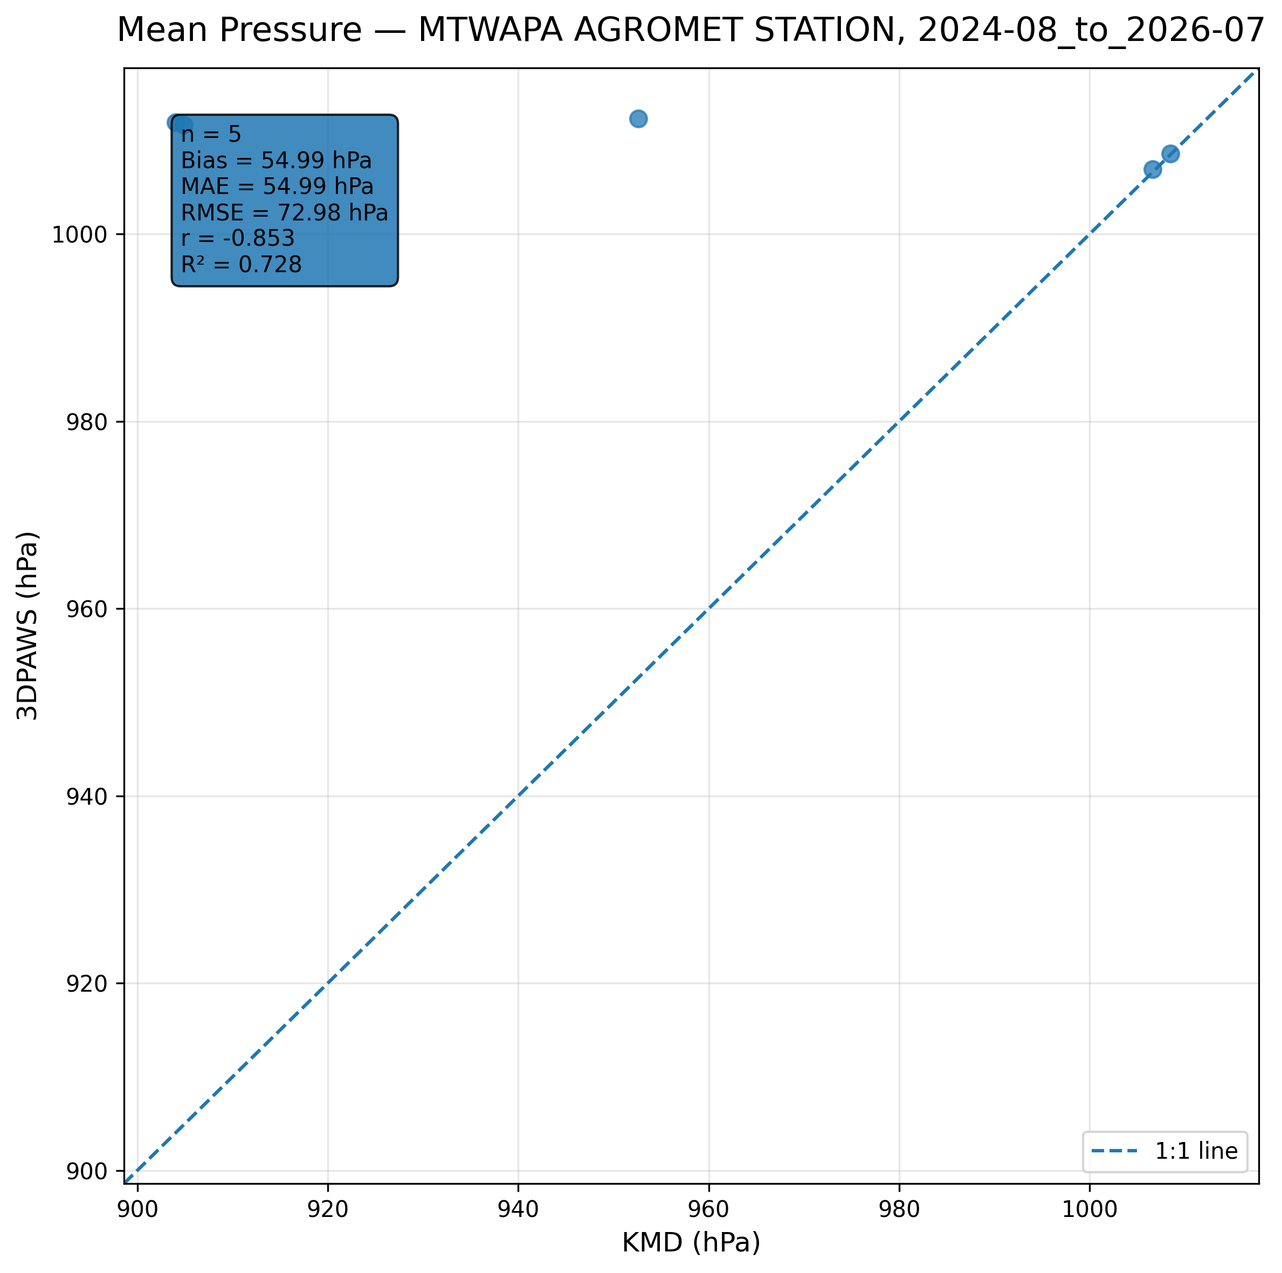
Figure 7.17: Scatter comparison of mean pressure observations between 3DPAWS and KMD at MTWAPA AGROMET STATION for 2024-08_to_2026-07.
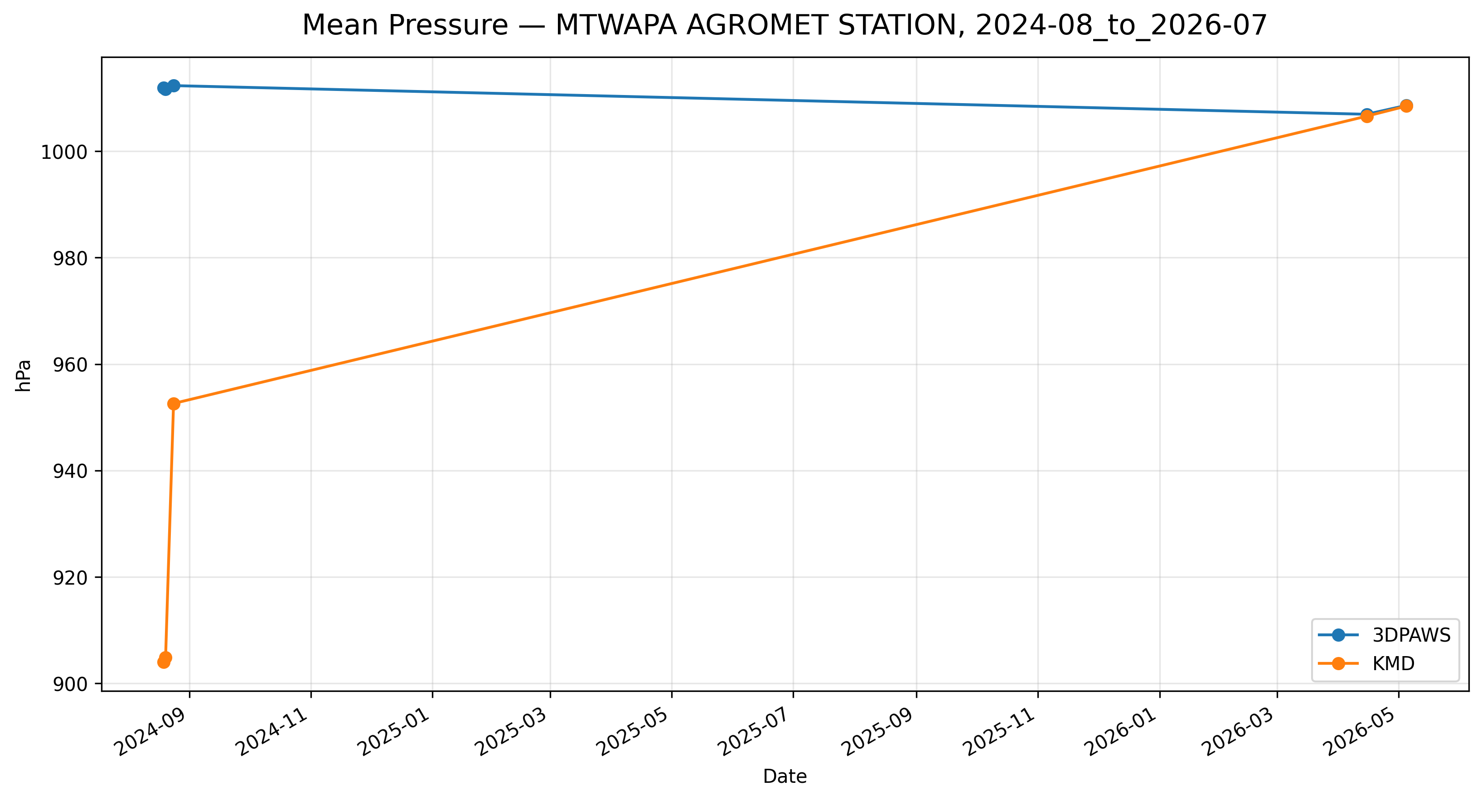
Figure 7.18: Time-series comparison of daily mean pressure observations between 3DPAWS and KMD at MTWAPA AGROMET STATION for 2024-08_to_2026-07.

7.7 Rainfall Results

Daily Rainfall (Rain Gauge 1)
Data status: AVAILABLE | Paired observations: 618 | Comparison missing: 100
Descriptive statistics
Statistic | 3DPAWS | KMD
Observations | 618 | 618
Mean | 2.071 | 3.455
Median | 0.000 | 0.000
Minimum | 0.000 | 0.000
Maximum | 99.000 | 115.400
Standard Deviation | 9.518 | 10.426
Variance | 90.591 | 108.694
Validation statistics
Metric | Value
Bias | -1.384 mm
Mean Absolute Error (MAE) | 3.208 mm
Root Mean Square Error (RMSE) | 10.028 mm
Correlation coefficient (r) | 0.506
Coefficient of determination (R²) | 0.256
Performance assessment: Below Threshold
WMO requirement: 244
Criterion | Value
Goal | 0.500 mm
Breakthrough | 2.000 mm
Threshold | 5.000 mm
Interpretation: The paired observations show moderate linear agreement between 3DPAWS and KMD measurements (r = 0.506). The coefficient of determination was R² = 0.256. The mean bias was -1.384 mm, indicating that the 3DPAWS observations were generally lower than the KMD observations. The mean absolute error was 3.208 mm. The root mean square error was 10.028 mm. Under the implemented performance assessment criteria, the parameter was classified as Below Threshold. Rainfall comparison should consider the event-based nature of precipitation and possible spatial variability between gauges.
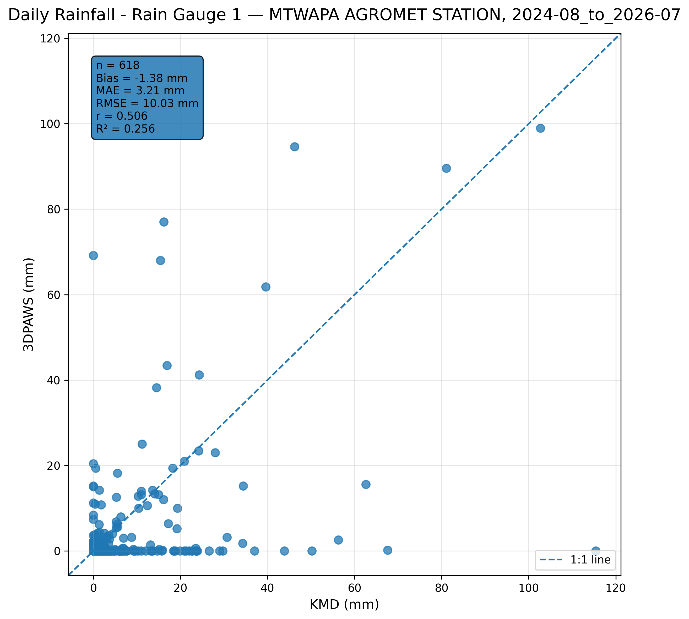
Figure 7.19: Scatter comparison of daily rainfall (rain gauge 1) observations between 3DPAWS and KMD at MTWAPA AGROMET STATION for 2024-08_to_2026-07.
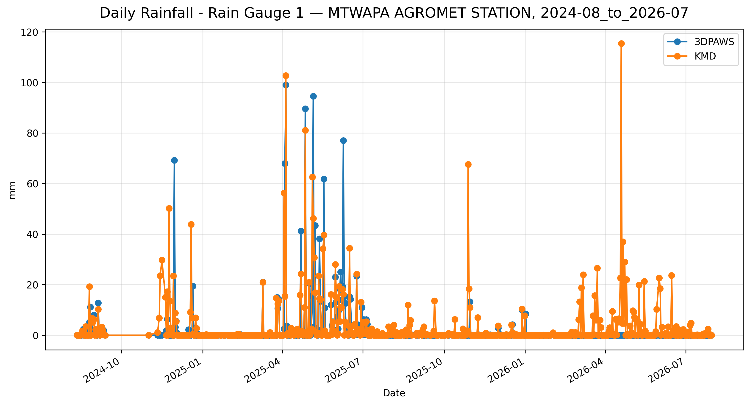
Figure 7.20: Time-series comparison of daily daily rainfall (rain gauge 1) observations between 3DPAWS and KMD at MTWAPA AGROMET STATION for 2024-08_to_2026-07.

Daily Rainfall (Rain Gauge 2)
Data status: AVAILABLE | Paired observations: 618 | Comparison missing: 100
Descriptive statistics
Statistic | 3DPAWS | KMD
Observations | 618 | 618
Mean | 1.598 | 3.455
Median | 0.000 | 0.000
Minimum | 0.000 | 0.000
Maximum | 98.400 | 115.400
Standard Deviation | 8.407 | 10.426
Variance | 70.675 | 108.694
Validation statistics
Metric | Value
Bias | -1.856 mm
Mean Absolute Error (MAE) | 3.193 mm
Root Mean Square Error (RMSE) | 9.821 mm
Correlation coefficient (r) | 0.492
Coefficient of determination (R²) | 0.242
Performance assessment: Below Threshold
WMO requirement: 244
Criterion | Value
Goal | 0.500 mm
Breakthrough | 2.000 mm
Threshold | 5.000 mm
Interpretation: The paired observations show weak linear agreement between 3DPAWS and KMD measurements (r = 0.492). The coefficient of determination was R² = 0.242. The mean bias was -1.856 mm, indicating that the 3DPAWS observations were generally lower than the KMD observations. The mean absolute error was 3.193 mm. The root mean square error was 9.821 mm. Under the implemented performance assessment criteria, the parameter was classified as Below Threshold. Rainfall comparison should consider the event-based nature of precipitation and possible spatial variability between gauges.
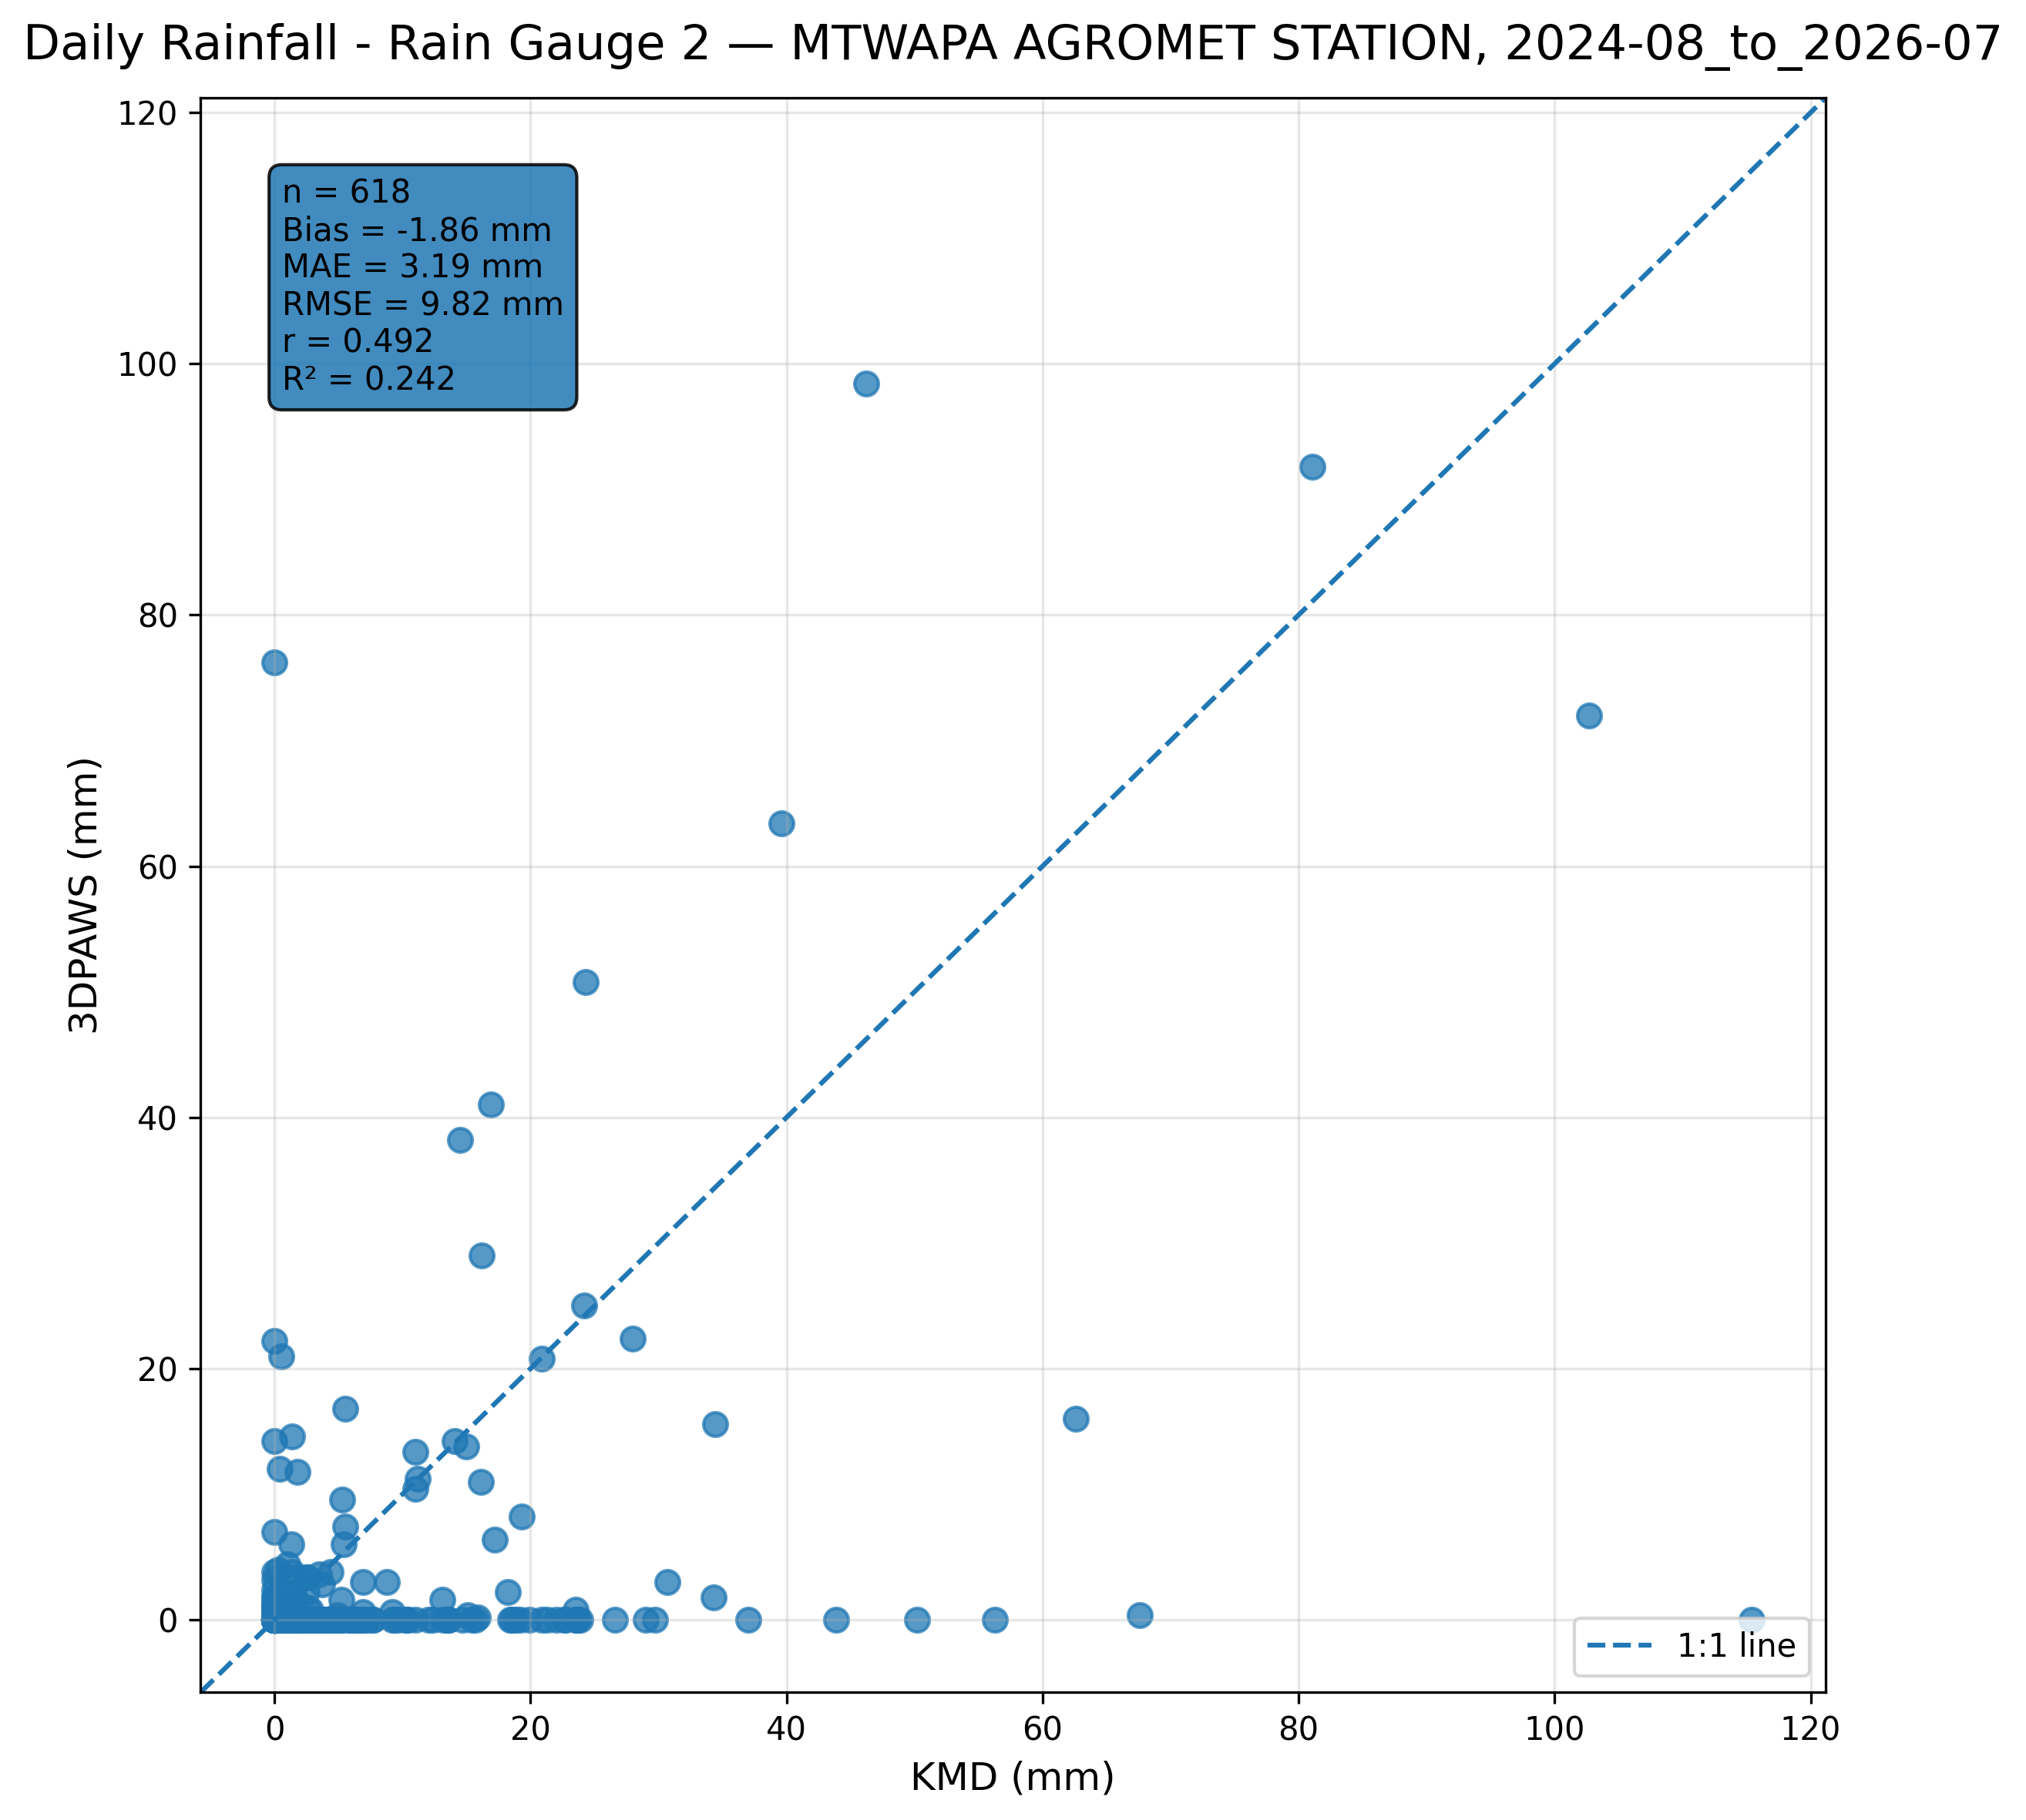
Figure 7.21: Scatter comparison of daily rainfall (rain gauge 2) observations between 3DPAWS and KMD at MTWAPA AGROMET STATION for 2024-08_to_2026-07.
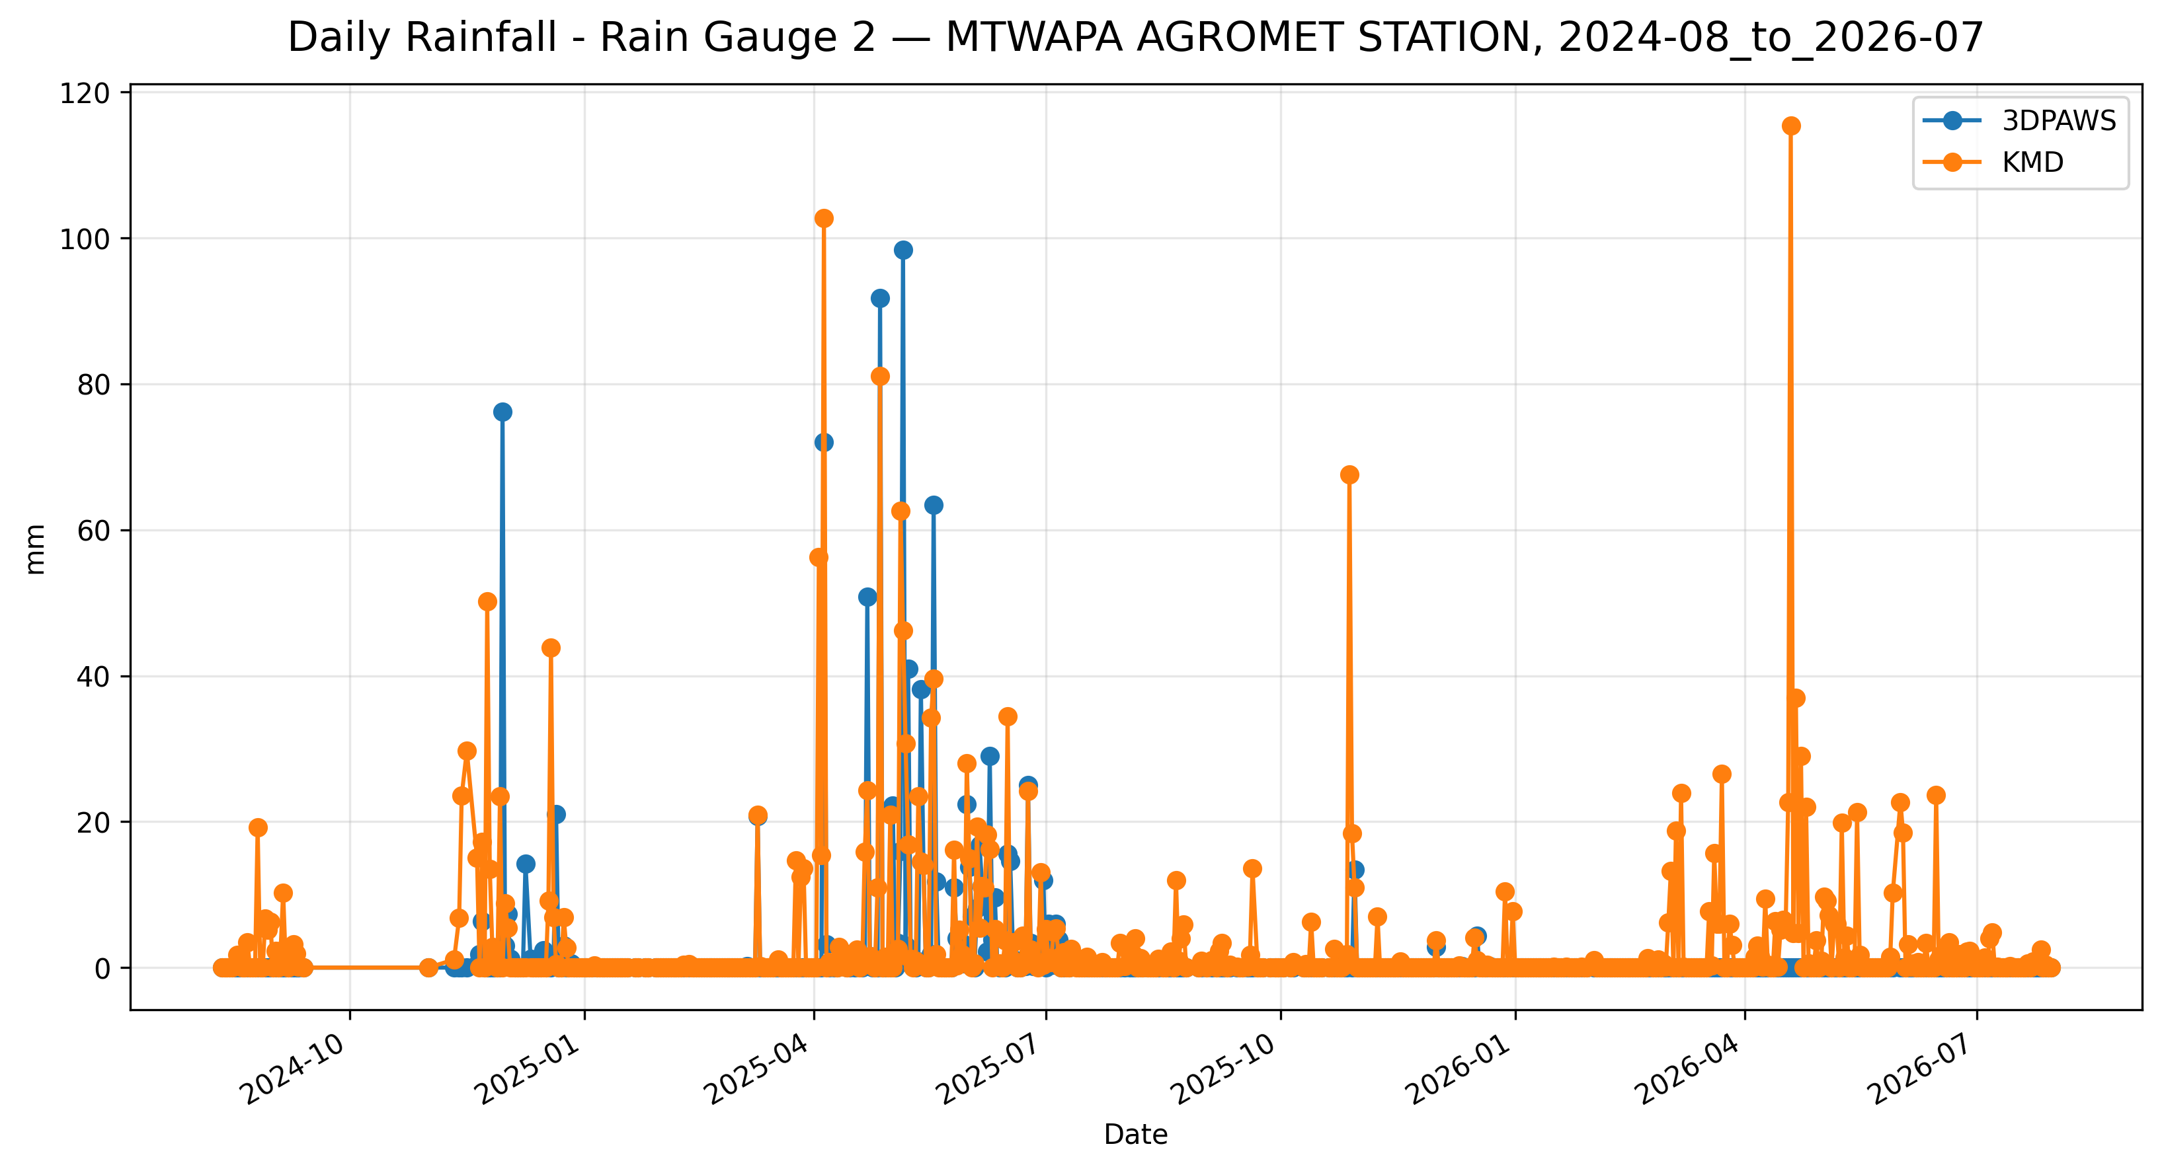
Figure 7.22: Time-series comparison of daily daily rainfall (rain gauge 2) observations between 3DPAWS and KMD at MTWAPA AGROMET STATION for 2024-08_to_2026-07.

7.8 Overall Validation Performance Summary
Category | Parameter | Paired | Bias | MAE | RMSE | r | R² | Assessment | Data Status
Temperature | Maximum Temperature | 160 | 0.555 | 0.763 | 1.206 | 0.843 | 0.710 | Threshold | ACCEPTABLE QUALITY
Temperature | Minimum Temperature | 379 | -0.240 | 0.623 | 1.074 | 0.725 | 0.526 | Threshold | ACCEPTABLE QUALITY
Temperature | Mean Temperature | 159 | -0.182 | 0.552 | 0.760 | 0.869 | 0.755 | Breakthrough | ACCEPTABLE QUALITY
Humidity | Maximum Relative Humidity | 566 | 24.001 | 24.005 | 25.271 | 0.232 | 0.054 | Below Threshold | HIGH QUALITY
Humidity | Minimum Relative Humidity | 566 | 0.397 | 3.924 | 5.994 | 0.654 | 0.428 | Below Threshold | HIGH QUALITY
Humidity | Mean Relative Humidity | 566 | 13.824 | 13.857 | 14.732 | 0.714 | 0.509 | Below Threshold | HIGH QUALITY
Pressure | Maximum Pressure | 5 | 58.184 | 58.184 | 75.801 | -0.932 | 0.868 | Below Threshold | ACCEPTABLE QUALITY
Pressure | Minimum Pressure | 5 | -31.480 | 31.480 | 43.380 | 0.924 | 0.855 | Below Threshold | ACCEPTABLE QUALITY
Pressure | Mean Pressure | 5 | 54.993 | 54.993 | 72.976 | -0.853 | 0.728 | Below Threshold | ACCEPTABLE QUALITY
Rainfall | Daily Rainfall (Rain Gauge 1) | 618 | -1.384 | 3.208 | 10.028 | 0.506 | 0.256 | Below Threshold | AVAILABLE
Rainfall | Daily Rainfall (Rain Gauge 2) | 618 | -1.856 | 3.193 | 9.821 | 0.492 | 0.242 | Below Threshold | AVAILABLE
The summary table presents the statistical performance of the 3D-PAWS observations against the KMD reference dataset. Bias indicates the average systematic difference between the two systems, while MAE and RMSE describe the magnitude of observation differences. The correlation coefficient (r) and coefficient of determination (R²) describe the agreement in observed temporal variability.
Performance classifications should be interpreted together with the statistical indicators and environmental characteristics of each parameter. Parameters classified below the implemented threshold criteria may still demonstrate useful operational capability, particularly where strong temporal agreement is observed.

7.9 Overall Station Performance Assessment
The overall performance assessment for MTWAPA AGROMET STATION was derived from the statistical comparison of individual meteorological parameters between the 3D-PAWS station and the KMD reference station. The assessment considers temporal agreement, magnitude of differences, observation coverage, and the parameter-specific performance criteria implemented in the validation toolkit.
The assessment is presented by meteorological parameter group. Within each group, the results are interpreted using correlation, error statistics, bias, and performance classification rather than relying on a single statistical indicator.

Temperature
Mean Temperature demonstrated the strongest temporal agreement within the temperature parameter group, with r = 0.869.
Mean Temperature recorded the lowest RMSE within the group (0.760 °C).
Mean Temperature showed the smallest absolute bias within the group, with a bias of -0.182 °C.
Temperature observations demonstrated useful agreement with the KMD reference observations. Differences in correlation and error magnitude indicate that individual temperature statistics should be considered separately when assessing station performance.
Performance classification: Breakthrough, Threshold

Humidity
Mean Relative Humidity demonstrated the strongest temporal agreement within the humidity parameter group, with r = 0.714.
Minimum Relative Humidity recorded the lowest RMSE within the group (5.994 %).
Minimum Relative Humidity showed the smallest absolute bias within the group, with a bias of 0.397 %.
Relative humidity observations demonstrated temporal agreement with the KMD reference observations. Differences in absolute values should be considered when interpreting measurement agreement and performance classification. Further investigation may consider sensor calibration, exposure, and local environmental conditions.
Performance classification: Below Threshold

Pressure
Minimum Pressure demonstrated the strongest temporal agreement within the pressure parameter group, with r = 0.924.
Minimum Pressure recorded the lowest RMSE within the group (43.380 hPa).
Minimum Pressure showed the smallest absolute bias within the group, with a bias of -31.480 hPa.
Atmospheric pressure observations showed differences in temporal agreement among the evaluated pressure statistics. Differences may be associated with elevation correction, pressure-reduction procedures, sensor response characteristics, and station exposure.
Performance classification: Below Threshold

Rainfall
Daily Rainfall (Rain Gauge 1) demonstrated the strongest temporal agreement within the rainfall parameter group, with r = 0.506.
Daily Rainfall (Rain Gauge 2) recorded the lowest RMSE within the group (9.821 mm).
Daily Rainfall (Rain Gauge 1) showed the smallest absolute bias within the group, with a bias of -1.384 mm.
Rainfall observations demonstrated the capability of the 3D-PAWS rain gauge system to capture rainfall occurrence and event variability. Differences in rainfall magnitude should be interpreted in relation to precipitation spatial variability and differences between the 3D-PAWS and KMD rain-gauge systems.
Performance classification: Below Threshold

7.10 Key Findings
The validation assessment conducted at MTWAPA AGROMET STATION demonstrated that the 3D-PAWS system reproduced meaningful temporal variability in several meteorological parameters when compared with the KMD reference observations.
- Temperature performance was strongest for Mean Temperature, which recorded the highest temperature correlation at r = 0.869. Mean Temperature also recorded the lowest temperature RMSE of 0.760 °C. The smallest absolute temperature bias was observed for Mean Temperature, at -0.182 °C.
- Relative humidity showed the strongest temporal agreement for Mean Relative Humidity, with r = 0.714 and R² = 0.509. The parameter assessments were Below Threshold under the implemented criteria. The results therefore indicate the degree of temporal reproduction achieved by the 3D-PAWS observations, while absolute differences should be considered when interpreting compliance with the applicable performance criteria.
- Atmospheric pressure showed the weakest temporal agreement among the evaluated parameter groups. The lowest pressure correlation was observed for Maximum Pressure, at r = -0.932. Minimum Pressure showed the closest agreement in absolute magnitude, with a bias of -31.480 hPa and an MAE of 31.480 hPa. These results highlight pressure reduction and elevation-correction procedures as areas requiring further evaluation.
- Rainfall observations demonstrated temporal agreement with the KMD reference observations, with Daily Rainfall (Rain Gauge 1) recording the highest rainfall correlation at r = 0.506. Differences in rainfall magnitude should nevertheless be interpreted considering precipitation spatial variability and differences between the 3D-PAWS and KMD rain-gauge systems.
- Under the performance criteria implemented in the validation toolkit, the assessment distribution was Below Threshold: 8, Breakthrough: 1, Threshold: 2. These classifications describe compliance with the implemented statistical criteria and should not be interpreted independently of temporal agreement, error magnitude, observation coverage, and the intended operational use of each parameter.
- Parameter-level paired-observation coverage ranged from 0.7% for Maximum Pressure to 86.1% for Daily Rainfall (Rain Gauge 1). These coverage differences should be considered when interpreting parameter-level statistical results.
Overall, the MTWAPA AGROMET STATION validation results demonstrate that 3D-PAWS was able to reproduce meaningful temporal variability across several meteorological parameters, particularly relative humidity, rainfall, and temperature. However, strong temporal agreement did not consistently translate into compliance with the implemented accuracy thresholds, particularly for relative humidity and atmospheric pressure. These findings indicate the potential of 3D-PAWS as a cost-effective approach for meteorological observation network densification, while highlighting the need for continued sensor calibration, refinement of pressure-reduction and elevation-correction procedures, further development of quality-control procedures, and evaluation across additional stations and environmental conditions before wider operational deployment.

